HAB (HIV/AIDS Bureau)
Health Resources and Services Administration

SPNS IHIP April Webinar
4/18/2019

Tinsley, Melinda (HRSA)

Submitted by:Simon, Nolan (HRSA) [C], Adobe Connect Team

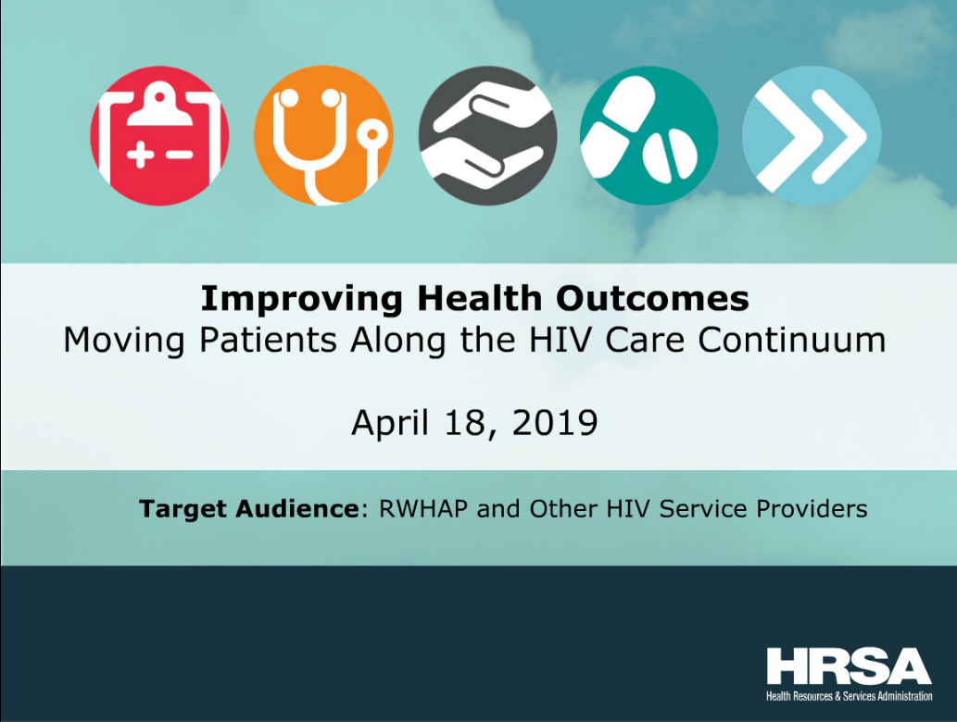

Event: SPNS IHIP April Webinar
Date: 4/18/2019
Event Coordinator: Tinsley, Melinda (HRSA)
Adobe Connect License: Meeting (<100 participants)
Unique Users: 35 unique users
Audio: Universal Voice/ Conference Bridge
Start and End Time: 1:30-3:00 PM EST.
Duration: 90 minutes
URL: https://hrsa.connectsolutions.com/spnsihip/

Problems Encountered with Adobe Connect Pro
No Problems Encountered

Recording

https://hrsa.connectsolutions.com/pkh40oe3is6p/
Attendees

principal-name
321736
Abigail West
Allison
Angel Johnson
Asya
Banita McCarn
Captioner
cheryl Betteridge
Eduardo Baez
H. Pacheco SCAETC
Ina Ramos
Jane Ward
Joanna Barreras
John Hannay, SPNS
Jovaun Matthews
Karina Tello-Medina
Laura Castillo
Manisha Maskay
Marian
Melinda Tinsley
Melissa Van Orman
Moira Mar-Tang
Nicole Mandel
Nolan Simon
Nsolomon (SPNS)
Pedro Coronado
Salina Tewolde
SMK
Stephanie
Taria Poteat
Terryl Chen
Tom Donohoe
Tracy Jungwirth
VAC - DH

Chat History

--------------- (04/18/2019 13:26) ---------------
321736: hello, how do I log into 2 versions of this log in method? it is possible?
--------------- (04/18/2019 13:37) ---------------
321736: are testing the audio yet?
--------------- (04/18/2019 13:40) ---------------
Laura Castillo: Hi This is Laura, how do I log in as a presenter?

Nolan Simon: Hi Laura, You've been elevated to presenter in the meeting

Angel Johnson: Laura. I'll send you the leader code
--------------- (04/18/2019 14:23) ---------------
Nicole Mandel: Martha's voice is quite low
--------------- (04/18/2019 14:26) ---------------
Angel Johnson: Thank you. We've asked her to speak up a little. I hope this is better
--------------- (04/18/2019 14:27) ---------------
Nicole Mandel: yes, thanks
--------------- (04/18/2019 14:41) ---------------
Stephanie: Hello. Thanks much for your great presentations. Did results vary in regards to different demographic groups? For example, young adults? At my agency, we have noticed this is a very difficult population to engage

Tom Donohoe: Can you please share how you set up your CAB? Any challenges/facilitators? Did you sustain it?

Salina Tewolde: What barriers did you encounter when implementing the intervention on an individual, group, and community level? Which intervention was hardest to implement and why?

Stephanie: Yes...
--------------- (04/18/2019 14:46) ---------------
Stephanie: Thank you both!
--------------- (04/18/2019 14:47) ---------------
Tom Donohoe: I would love to ehar how you used telenovela SIn Verguenza http://svseries.com/
--------------- (04/18/2019 14:55) ---------------
Pedro Coronado: Martha, as you implemented these tranings was there something that stood out from your audience after viewing the novela?

Polls

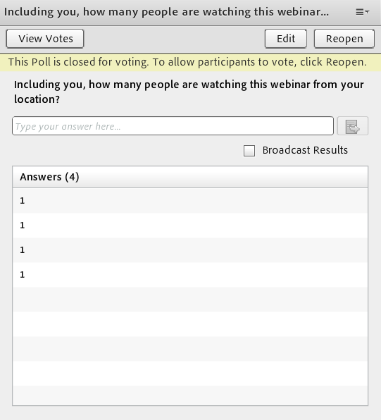

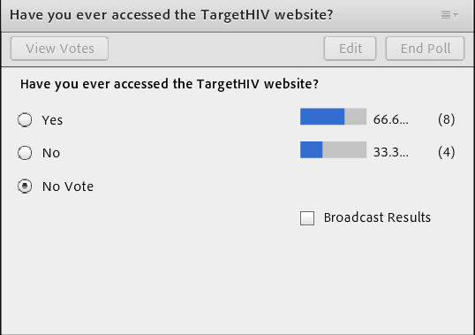

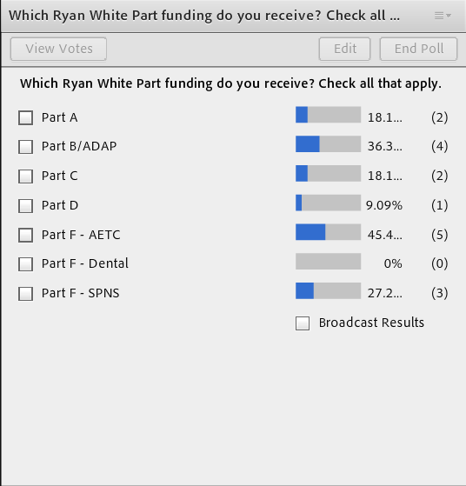

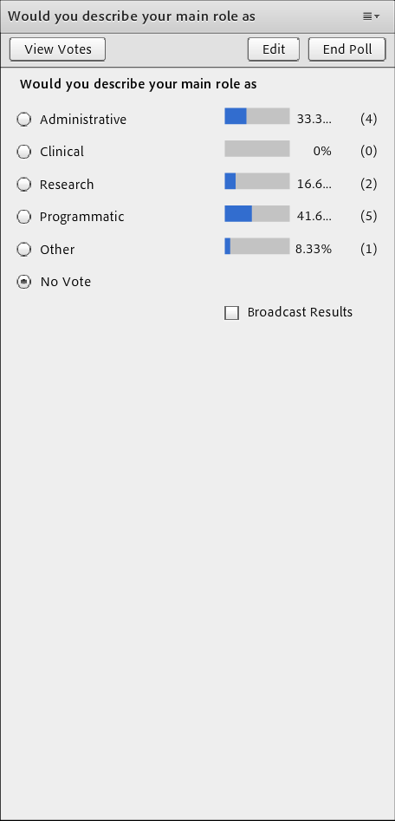

Q&A

Q/A Done Over the Phone

Transcript

We use motivational interviewing which provides practical guidance for helping an individual progress through the stages of change and the transnational factors affecting engagement and retention in HIV medical care, and Laura did a great job of describing trans-nationalism as a theory before me. Our activities throughout each intervention was tailored for our priority community to do three things, increase knowledge of HIV in the community, increase perception of risk, and decrease stigma related to HIV. This slide demonstrates examples moving from left to right. Efforts through our community level efforts and as you can see, our messaging even within our parts really reflected the community and concerns dealing with immigration status and inability to pay to let them know that we were established and prepared to help them regardless of their concerns. In the middle section, that reflects our community level, our group level intervention, excuse me, and our efforts to educate the community using culturally relevant and culturally respectful strategies that connected to those themes and important connections to our Mexican culture including the development of a unique, our very own Mexican bingo to discuss concerns within the community related to accessing medical care and a wonderful tele-novella already made available by another organization thanks to CDC funding which we used to our advantage, which we used to delve into a difficult situation using the topic of a soap opera that delved into HIV in the Latino community and at this community level, all of our messaging through our print and radio campaigns spoke directly to the community. We developed scripting that delved into everyday situations and various relationships and how we could bring up the topic of routine testing and the concerns related to HIV and leaving those concerns, removing the harsh spotlight off of HIV and making it about health and community. So outcomes at the individual intervention level is we served a total of 123 individuals. Our goal has been to enroll 120. We have enrolled into the study 104 individuals. Based on our nine question survey regarding client experience at the individual levels, we have 97% satisfactory response rates. One challenge and solution we wanted to really reflect on is that initially, at the individual level, we were designed as a highly, as a time-limited intervention. And yet, we had to remain highly focused over extended periods of time, intervention, through use of community health workers. And it ended up taking a much more active extended role in order to ensure engagement and retention. The two images to the right reflect some of our numbers as far as a newly diagnosed versus previously diagnosed. And a very preliminary one year outcome among participants that met the definition at baseline. Within our group level intervention, we provided 18 full education courses engaging over 200 priority community members through each individual session. The course was submitted to the Texas Department of State health services for continuing education consideration for community health workers and their instructors, and we were awarded 14 community education units which is wonderful, because for us, the big challenge at this level was, how do we engage more people from our community in this dialogue? So we developed connections and partnerships that have given us entry to the network of certified community health workers and instructors in the state of Texas. As you can see from the image on the bottom of the slide, we count several key partners including the Texas Department and state health services, the office of border public health and the south-central aides education and training center. At the community level, I know my time is running short, we have reached engaged and educated many in the community , 607 have tested as a result of our direct involvement in the community. And we've done a lot of testing, engagement, and reminders. We have seen an increase in Latino statistic in partnership with the efforts. As you can see within the image to the right and the years prior to Viviendo Valiente's involvement in outreach activities, our testing tested printer 76 and 444 Latinos respectively, and in the years following, it almost doubled in some of the years. For us, very early, our challenge was how to support the third strategy, take action beyond providing education and promoting dialogue. Our solution was to join forces with our testing teams as often as possible when working out in the community. As far as sustainability, the missing, the mission in the Prism Health North Texas is about the advancement of health and it places special emphasis on education and prevention of personalized care, all of which are key elements . Sustainability remains at the forefront from the conception of our program and we were challenge from the beginning to consider each one of our strategies fit within the agency's scope and whether it was sustainable beyond grant funding. And this focus on key elements that can be maintained or could help improve upon our agency standard of care was seen as vital. Of course sustaining those essential elements requires engagement of stakeholders besides looking for collaborative opportunities with as many teams as possible, we developed and maintained active advisory boards for feedback. At another opportunity involves that of refinement of processes and elements that can be sustained by the organization. That is where we are now. As far as lessons learned and recommendations that we would like to leave with you, to form strategic partnerships at conception and throughout, personalize and nurture this partnership by knowing who you are going to ask for help, being familiar with their goals and their mission. Develop a cohesive and consistent messaging that aligns with what you've learned from your priority population, and maintain active community advisory boards. We also encourage you to maintain responsiveness and flexibility both within the members of your community, your staff, and in regard to program implementation. And with that said, we have a lot that we would like to share . So if you have a specific questions about our program, please know that we have multiple resources available to you, and I am available to speak with you directly, should you have questions. And with that said, thank you so much on behalf of our team here at Prism Health North Texas . That is all from me. Thank you.

Thank you, Martha and thank you, Laura, for sharing your programs and for your great presentations. Before we open the lines for questions, please note the link on the screen and we would love it if you would use this to give us your feedback on today's webinar. We will mail this link to anyone who registered to participate in the webinar following this presentation today. So operator, can you please open the lines for any questions that our participants may have?

Thank you. We will now begin our question and answer session. If you would like to ask a question, please press star one, unmute your phone and record your name slowly and clearly when prompted, your name is required to introduce your question. Again, that is star one if you would like to ask a question. One moment, please.

And I would like to remind you that you can type your questions into the chat box, and we will be able to read those questions to our presenters and you can still get your responses that way. If you don't want to speak, you can go ahead and type in a question. And I think we are getting a question now.
So while we are waiting for Stephanie to type her question, I have a question for Laura, Laura, what recommendations can you give to making a program like this sustainable over time?

Something that I didn't talk about when I mentioned trans-nationalism as it pertains to this particular project was incorporating Mexican cultural components because those really show a correlation in terms of the medical care and medication. So for instance such components like building, when I was talking about building the report, recognizing that there is but she's mellow and fatalism, and something crucial was the staff retention. When you have staff working with participants for a long time, 18 months, it can create a sense of unfamiliarity and it is more effective to be working with one or two people versus six. I feel like those are at the forefront for sustainability and being prepared, for instance, we had some participants that unrolled toward the end of the project, but because we have the CDC funding, we could transition them over to continual linkage.

Thank you for that. So we have a question, we have a couple questions. We have one from Stephanie, thank you so much for your great presentation. The results vary in regards to different demographic groups, for example, young adults. At my agency, we have noticed this is a very difficult population to engage. And I imagine this question would be for either of our presenters.

This is Martha. If the question about how to engage at various ages? Is that why understood?

How did you and Kate, is it, the results vary in regards to different demographic groups, and then she said young adults as an example.

That is an excellent question. And I really think it is about from conception and looking at what your assessment is a saying about what is important to your community overall, so while there might be varying ways of personalizing a message let's say for my grandparents versus my parents versus me or my child, what remains consistent for the community is what binds them together. And for us, what came across from our community is that what binds them together is that the love for their families and communities. So we created consistency in our messages that included love and motivation of the community as a whole and the family rather than creating very individualistic messages. And our education strategies, we reverted back to what is tried-and-true in our community, which was the use of games that the community connected to already. That was something that could be used with, from children to grandparents. And then we also used tele-novella which in the community is watched by every age group in order to delve into the topic of HIV in the community. That was our choice to make very early on, and our experience is that it really did engage individuals at every level. Thank you for your question.

Thank you, Martha. Aunt Laura, did you have any response for that question as well?

I wanted to share that we didn't really notice a difference in terms of engagement success or linkage as it pertained to demographic groups, but for our end, what we really saw play a role work areas like homelessness and poverty and substance abuse. And it really depended on where they fell in within the federal poverty level. Many participants held more than one job and at times it would be very difficult to find medical apartments where they could go later in the day, especially if they were just getting linked to medical care where you have to go earlier in the day. So what we tried to do for those that have substance abuse problems for instance, we would engage in sessions with them and coordinate so they would see the therapist and substance abuse counselor right after so they would save a trip without having to come back again. So with homelessness, being out of touch and not having a phone, not knowing when we would see them again, really coordinating and working as a team so we would know when someone would stop by unexpectedly and be able to readily assist them and support them. At a demographic level, not something that was very evident. It was more so at the needs level.

Thank you, Laura. So Tom Donahue is asking, can you please share how you set up your CAB? Any challenges/facilitators? Did you sustain it?

Thank you, Tom, for that question. We actually have two community advisory boards, one external advisory board and one internal. And we used our staff members who are very active in the community to alert us as to individuals that could be nominated for that advisory board. They were interviewed. They told us about their interest about their knowledge of the community before they were accepted onto that advisory board. For the internal advisory board, we really got a great response from our internal team members at prism health North Texas that reflected our priority community in their background and that also had many years of experience in serving the community. So across the board, we thought and looked to retain individuals that already expressed and demonstrated a sincere goal of assisting our community through their endeavors. So it was easy for us to maintain them actively involved in providing feedback to us.

Thank you.

And that's it from me.

Thank you. Any other responses?

I also wanted to share that we have a cab as well, and although I didn't discuss it as a key component, our CAB actually provides feedback or insight throughout the services agency wide. In terms of how we set it up, we look for community gatekeepers or participants in support groups are the most active and involved. And they are just constantly coming to the agency, because we know that they have a lot of insight to provide and share with us, knowing how we can improve, how we can and quality services and whatnot. Our program participants, most of them go to different offices and as I mentioned, we have six centers. So they are able to see how we are operating throughout LA County as an agency.

Thank you, Laura. Another question, what barriers did you encounter when implementing the intervention on an individual group and community level, and which intervention was hardest to implement and why?

In Prism Health North Texas , at the community level and at the group level, I wouldn't say that there were barriers. I would say that there were opportunities to really look at what our community assessment told us and defined really not just culturally relevant, but culturally respectful ways of addressing those things that the community assessment told us they were afraid to address, and that was the discussion, the topic of HIV within their families. So we had to be very creative and thoughtful in how to address that. And the way we thought to overcome that was by becoming very confident in our discussions about the topic of HIV. So in essence, becoming models of how you can address the topic, how it should be discussed, and how to address those things with the people that we love the most. At the individual level, also with me is the doctor who can talk about some of the other things within the individual level intervention, but it really is about sustainability of being able to spend more time with a certain communities and listening to their stories. Oftentimes we have a very limited time with them, and as Laura mentioned, it really is a key element that has to be sustained. It is not only important at the beginning, but we really have to take the time to listen to them and to address things in a culturally relevant matter. I wonder if the doctor would like to add to that.

I think what else was helpful was that our promoters would meet with our clients at the times that they needed to be met with. And they would meet them also at the clinic, even though the claimant, clinic was within North Texas, it really helped when our promoters went with them. Including to the pharmacy. And other places like that, so they provided a lot of advocacy, a lot of support, and a lot of guidance for our patients to be effective consumers.

Thank you Doctor and Martha. And then so Tom would love to hear how you use tele-novella, I'm not sure --

That is very close. Yes, so we could not have been more thrilled, anytime we find any activities or resources that have already been developed with a lot of love and knowledge, we holistically believe in utilizing those resources so we don't have to reinvent the wheel. So for us, we found Sin Verguenza
which was developed by ultimate, at least the first season was, and honestly, it was perfect, because our sessions that we developed were four separate sessions, and the first season of the soap opera, Sin Verguenza, which means without shame , and it also has a double meaning that means shameless, really. Someone who lives without shame. And we were able to tack on those four episodes, all of which were anywhere between 5 to 7 minutes at the tail end of the session because technically, our sessions could stand alone even though we built them so that, or we develop them so they could be building blocks. So as we tip them deeper into the HIV conversation and started out from health which was an easier topic for our community, and what we did was we injected each one of those tele-novella episodes at the tail end, because anyone who ever watched a good soap opera knows that each episode ends with a cliffhanger. And so what we found was that most individuals returned for each successive session because they wanted to know what happens with that tele-novella, and the tele-novella dealt specifically with HIV impacting a community, a Latino community. So it was already something that connected dearly to everyone in our audience. So we are again very grateful for those things that are already out in the community, and we found it to be a gym for our group level intervention. Thank you.

I just wanted to say that it was very brilliant that you incorporated Sin Verguenza and that you were able to adapt this initiative at the community level. It definitely provides a lot of insight, because on our end, it, we thought that at the individual level would be pretty much the way to go and it made complete sense. But I appreciate how it can be adapted to fit the community level needs. So thank you so much for sharing about that.

Thank you.

Yes. Thank you. And to follow that up, Pedro is inquiring as you implemented the training with something that stood out from your audience at the end of viewing the novella?

So what we usually are doing when we watch a soap opera or tele-novella is we really are tackling difficult topics to the other individual that has nothing to do with me, it has some other family that's dealing with this topic and eventually what we see with tele-novella is that it becomes more engaged in the story line and you start dialoguing after the tele-novella or sometimes through it, you start piecing parts of your own story to that tele-novella and relating to it. That is why we engage in those tele-novellas, because ultimately it is a reflection of true life. And what we found as we became more engaged throughout each individual session was that not only were they receiving information which was our three-point strategy, we were providing education, we were engaging, and activities that allow them to then talk about what they were learning and how it related to their fears and concerns and knowledge, and then the tele-novella allowed them to take action in some way at the end, because it would then really processed the fears that they had, but it started off slowly with the first episode, again, because they were first being introduced to that topic, but by the fourth session, it was very engaged. They began to associate their own personal connections with loved ones and people that they knew, we would oftentimes hear about people that they knew that believed would really benefit from the message, because they had, they were seen as being high risk or concerned, some even shared that they knew individuals who were living with HIV. So it really became a moment of release by the end of our session.

Thank you for that question.

And thank you, Martha and Doctor, I think that is quite interesting. So we have a couple minutes. We have some really good questions. If there are any other questions, please feel free to type them in, we may have time for maybe one more or if someone on the line as a question, that would be great. In the meantime, I just want to let the audience know that both the slide deck and webinar recording will be available at the target HIV website and we ask that you allow 3 to 4 weeks for the materials to be posted. The next webinar in the series is scheduled for next month. We do not have an exact date at this exact time, but as soon as it is available, we will get that information out to you and hope that you will be able to join us at that time as well. And are there any other questions? Or any closing comments from any of our presenters, or anyone else?

I'm sorry. -- I just wanted to thank you for this opportunity. We are very grateful for all of the different efforts that are being made on behalf of our different communities that are impacted by HIV, and we are just grateful for your time and hearing our story, and we look forward to further opportunities to share more about our strategies with you at any time. Thank you.

And I thank you. Someone else had something to say?

If no one was going to say a question or ask a question, I also wanted to go ahead and thank everyone for really allowing us to share what we've learned. It was truly a remarkable initiative that further enhanced our skill set to better serve the needs of this community. This has really been transformative in our agency as far as lessons learned and just how to improve our service delivery. This project pretty much kick started my public-health career on high mode, and I just wouldn't be at the place I am right now in being able to better serve the community without this initiative. And everything that was discussed and everything covered with clients, troubleshooting complex situations which, of course, no material or training can prepare you for, that is life, and so it was a remarkable initiative that really has changed so many lives.

Thank you so much everyone. And thank you to the presenters and thank you to the audience. This concludes today's webinar. And if you have additional questions after the webinar, please don't hesitate to contact the contact. >>, That concludes today conference, thank you for participating. Have a nice rest of the day, and speakers hang back for your post conference. One moment, please. [ Event Concluded ]

