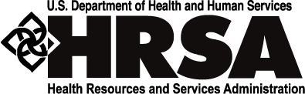

HAB (HIV/AIDS Bureau)
Health Resources and Services Administration

SPNS/IHIP Webinar Series
5/13/2019

Tinsley, Melinda (HRSA)

Submitted by:Patel, Saeed (HRSA) [C], Adobe Connect Team

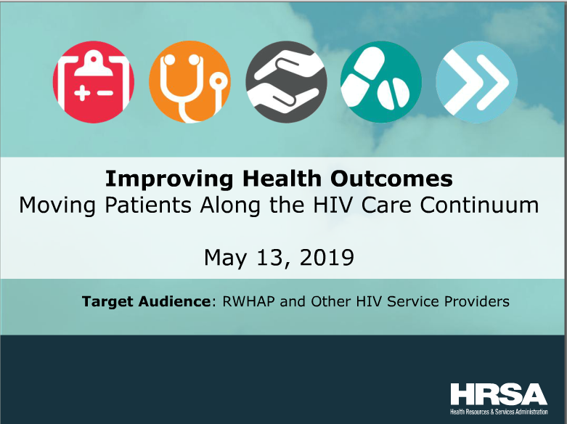

Event: SPNS/IHIP Webinar Series
Date: 5/13/2019
Event Coordinator: Tinsley, Melinda (HRSA)
Adobe Connect License: Meeting (<100 participants)
Unique Users: 29 Unique Users
Audio: Universal Voice/ Conference Bridge
Start and End Time: 1:30 PM – 3:00 PM EST.
Duration: 90 Minutes
URL: https://hrsa.connectsolutions.com/spnsihip/

Problems Encountered with Adobe Connect Pro
No Problems Encountered

Recording
https://hrsa.connectsolutions.com/ptbfyjj6jgom/

Attendees
7842807
Amy Baker
Amy Sgueglia
Andrea nORBERG
Angel Johnson
Captioner
Christian B. Ramers, MD, MPH
Darnelle Delva
Hathy Simpson
jill
Jovaun Matthews
Kym Hodge
Marcia Louza
Marliese Warren
Melinda Tinsley
Melissa
Mikey
Saeed Patel
Sarah
Sarah Cook-Raymond
Shannon Fuller
Shannon Ransom
Shelly Kowalczyk
sherry Kwakye-Berko
sklinedinst@cardeaservices.org
Verna
Victor Ramirez
Wayne Steward
Yasmin Flack
Chat History
----------------- (05/13/2019 13:42) -----------------
Verna: Has the presentation started? I only hear "hold" music.

Verna: I see the slide presentation moving forward.
----------------- (05/13/2019 13:45) -----------------
Angel Johnson: We'll get started at 2:00 PM.
----------------- (05/13/2019 14:49) -----------------
Andrea nORBERG: Thank you for presenting today. Darnelle can you share more details related to the workaround to EHR enhancements?
----------------- (05/13/2019 14:50) -----------------
Andrea nORBERG: Norberg...yes
----------------- (05/13/2019 14:52) -----------------
Andrea nORBERG: Very helpful. Thank you-Andrea

Polls

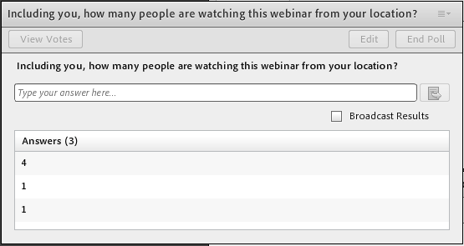

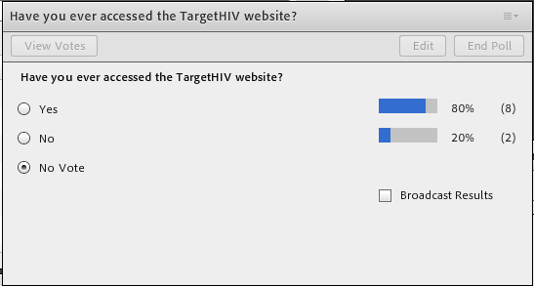
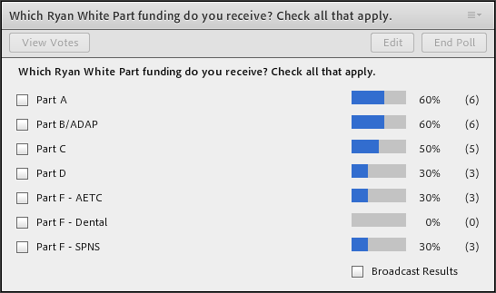

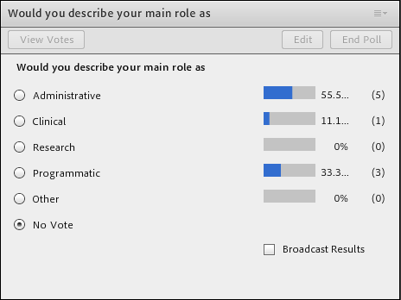

Q&A

Q/A Done Over the Phone

Transcript

Captioner and CAP TIONERVI TACPlease stand by for realtime captions.
>> Welcome and thank you for standing by. At this time all participants are in a listen only mode until the question-and-answer session of the conference. At that time you may press*one to answer questions. I will now turn the commerce over to Angel Johnson. Said thank you and good afternoon everyone. My name is Angel Johnson and I will be moderating today's webinar on improving health outcomes. This is the second webinar in our four part series brought to you by the Herscher -- her subprogram. But now we have the brief poll questions on the screen and if you haven't already please go ahead and complete those. There are two ways to listen to the webinar today. We had the information on the screen with both the number and the passcode, or you can enable your computer audio to listen to your speakers. This webinar is being recorded and will be available for viewing on the target date of the website in about 3-4 weeks. As operator mentioned earlier all phones are in listen only mode, and will hold the questions to the end of the webinar. However there is a chat bar to the left of your screen that will remain open. If you have a question during the presentation, you can submit them in the chat box and we will address them. Finally at the end of the webinar will -- we will provide a link and will greatly appreciate it if you take a minute to complete that form. We will send the link via email to all participants. We are going to get started by removing the polling questions from the screen. Thank you. For today's agenda, I will provide a brief overview about the SPNS program and integrating HIV initiative practices project, or IHIP. You will then hear from our presenters who will discuss their workforce expense. Our first resume today is Doctor Christian Ramers from San Diego California . He is at the family Health Center of San Diego, a large federally qualified health center system serving nearly 200,000 medically underserved individuals throughout San Diego County. In this role the doctor serves as a primary care physician and a consultant for patients living with HIV, and HCV and for those who are homeless or on drug and rehabilitation programs. He is board certified in internal medicine, pediatrics, and infectious diseases. He is an American Academy HIV specialist and is particularly interested in HIV, HBV, HCV, and the service of medically underserved immigrants and refugee population. We will also hear from Darnelle Delva with right point help. She is an expense quality improvement coordinator and in this role, she leaves and facilitates that data-driven facilitation of workflows and project improvement project aimed at process improvement and documentation and quality of patient care. Darnelle oversees ongoing evaluation and quality assurance of the AIDS, preventive care, and care management grant funded program. Following these presentations, we open the lines and take questions. The calendar program is funded to the Y and -- Ryan White program and addresses the evolving nation of our healthcare delivery system. The SPNS program remains current by addressing emerging issues in HIV care and populations most affected by HIV. Initially, the calendar program was challenged by finding ways to effectively disseminate ways and the lessons learned to help other providers replicate these innovations. Through the IHIP program 11 supports audible implementation of these models. These include developing tools and resources like implementation manuals and guides and faxes to encourage replication engage stakeholders to increase each of these tools to support the replication of SPNS models. As I prepare to turn things over to Doctor Ramers, I want to provide you some information to stay connected to 11 or IHIP. If you have any questions about the webinar, please send them to the email and for additional information to sign up for the IHIP to receive the latest analysis but that's make about training, please visit the target Center at target.HIV.org/tran12. To learn more about 27, visit HRSA.gov. Now without further delay, I will turn things over to our first presenter with family health services and MET follow him you will hear from Darnelle Delva. Doctor Ramers.
>> Thank you so much and thank you for the opportunity to present my work and I am resenting on the behalf of my colleagues. Hopefully you are listing to this to become inspired to address work force issues in the field of HIV whether or not you are from a Ryan White fund the clinic and you want to expand, or from a primary care environment and want to get into doing HIV care. What I want to do is share what we have experience in trying to address these issues and hopefully inspire you to take action. First that disclaimer and this work was funded by a grant from HRSA over four years starting in 2014 and finishing four years there after. This information and conclusions are really those of the author and should not be concerned with the official policy of the government, or HRSA. Here is an outline of what we will talk about today and we will start with an overview of the situation we face in San Diego and many of you are facing in offering HIV care. We will talk about capacity and what is needed to start to make change and think about change. Then we will go through the implementation of our particular project with respect to medical providers, support staff, and then really talk about some adaptations we had to make along the way, corrections, and some successes. Very importantly we will get into sustainability and share our lessons learned and recommendations in certain areas. Been at the end we will have some resources and then I will turn it over to Darnelle. A little bit of background in our environment. Work and family health centers in San Diego, which is a private 501 federally qualified health center in San Diego. We operate 22 primary care clinics throughout the county, and we are the largest provider of HIV services in San Diego County including clinical care as well as HIV case management and HIV testing and preventive services. In our main clinic we care for approximately 1300 people living with HIV per year. Our patient population is really racially and ethnically diverse and low income. Our goal of this project was to expand the capacity of our organization to provide specialty care to system-level structural changes. The way that we approach this is we felt we had to have a multi-prompt approach training rhyming care providers and family medicine residents to provide HIV specialty care, and have more systemic changes to expand care from one to several different clinic sites. In order to do so we had to train support staff at these sites in HIV services. I should mention that we are facing a situation as I'm sure many of you are across the country where our more experienced HIV providers for the generation before are nearing retirement, and it is that this is the as a mother of invention that we had the three providers that was leaving and we have to fulfill this And train an additional workforce to carry on HIV support in the future. So what are the capacity requirements for success? This is a little bit of our lessons learned in the front and I wanted to share this with you early on. There is two main areas and the agency itself looking at your own environment, you have to buy in from different levels of the agency, from the leadership, the staff, clinic directors, supervisors, and the providers. You certainly need the raw materials to expand the workforce and the raw materials are the clinics and medical providers being willing to initiate HIV medical care. We felt it was really important to have a physician champion or someone who can authoritatively train the staff, or the use of an external HIV specialist as possible as well. Within your organization it is very important that the staff champion from nursing in order to train their colleagues. Funding is honestly very important here. Funding is necessary to pay for people's time, specifically the HIV physician champion or external specialist needs to have dedicated time, which is supported financially in order to train. The existing medical providers if you are pulling them out of usual clinic hours, that needs to be backfilled in our situation with providers. In terms of support staff if we are pulling them out for training and doing this outside of business hours, we need to compensate people for the time. Finally if you are going to be bring in an external people or agencies to train support staff, these need to be compensated as well. It is not all bad news. There are a number of elements with respect to capacity that are free and available, and we will call these more resources. On the top here you can see the ones that are spread across the country and available and willing to help with training needs. There is a national HIV curriculum that can be found at the website, and is a great source of material to use in training. Something that we found useful is that although during the actual time of the grant time was compensated for, and what you create a mentoring relationship, people work together off of the clock so to speak. Our HIV specialist champion is able to continuing mentoring after the training is complete. The American Academy of HIV medicine has many resources available for training, and what you create a culture of learning and inspire people to share cases with each other, there is internal education and reviews that continue to occur as well as other programs out there, and the one that we use is the Pacific HIV learning network. In terms of resources for the support staff, it is very important to survey your own resources and see which existing staff can lend their expertise to train their colleagues in terms of internal process, patient flow, insurance, HIV programs and referrals. There is many curriculum out there already, and we allow on the local agency at the University of California at San Diego as well as a center that has developed other training. Finally, using our own staff champions be willing to be trained by other staff is a very important aspect a little more into the detail of our model. We split it into the medical provider training as well as the staff training. Our medical provider training, the curriculum was multimodal and longitudinal, and it was to culminate the HIV medicine specialty certification for all of those that undergo this training. We have to have a family residency of six residents per year and our site. Their training has to be spread out over two years, and our second year and third year residents are involved in four existing primary care providers, we pull them out for only six months at a time to complete their training. The methods here were a combination of immersive clinical preceptorship time with one -2.5 days per month progressing to in Panama where they took ownership of their own patients. There was a fairly high level of independent study that was an expectation of this program. Pilot because we have an ongoing mentorship among our specialists and trainees, ongoing specialty consultation to provide that extra support once he primary care providers are out there doing HIV care. In terms of the independent study that was expected, I mentioned some of the resources already, and there is an online curriculum introduced by the University of Washington, and they also have a question bank for people to assess their learning. A specific AETC network provides telehealth services every two weeks which will bounce cases over experts and review topics. There are recorded sessions that have been produced by the Northwest AETC which is now called the Mountain West AETC. Little D- 20 minute topics from all HIV areas. There is additionally overlapped with hepatitis C content and we relied on the University of Washington curriculum as well, and we developed our own internal resources which we call the HIV huddle which runs inside of our own clinics. For the clinical support staff we took a slightly different approach. We did a rolling curriculum up to our sessions in person and online roughly once a month for period of six months. Some of the topics you can see listed below with a lot of assistant from the Pacific AETC to round some of these as well as the Coldspring center. Along the way we had to make a couple of adaptations to maintain [indiscernible], and are provider schedules are difficult to arrange so we had to make some modifications in our existing providers we originally planned on keeping them for a year, but it turned out we could get most what we needed accomplished in six months, and that also saved a little bit of money not having to backfill their time with per diem. Resident curriculum was going to be a year originally, and we moved it to to two years for scheduling purposes. For staff training we offered repeated courses of the refresher possibly because of misalignment of timing versus training and having HIV patients in the clinic, and also partially because of staff turnover. We did have some successes along the way and trained 11 providers and they are all practicing at the end of 2018 seeing HIV patients and among staff we have trained 185 individuals and our clinic sites have expanded from one site:in 2014 that was sitting HIV patients, up to seven clinics offering HIV specialty care. You can see some of our quantitative results here and the number of unduplicated HIV patient be cared for in our rhyming care clinic, likely ramped up to the four years of the program to the point where we are close to 400 individual patients receiving care outside of our centralized HIV clinic, and on the bottom you can see the number of actual encounters this translates to to speak the language of clinic directors. Sustainability is really important here, and I am going to share with you the positive aspects of sustainability and I will address it at the end. Since we have a family medicine residency, we have a structure in place that will allow us to continue attractive training for family medicine residents coming in and this is partially because once the curricula has been accomplished, the scheduling can be built into the existing residency program. We have two of our six residents per year that continue own a HIV track of the goal is to obtain HIV certification at the end. A physician champion is still available to continue mentoring, and now we have a lot of HIV trained specialists which can pre-accept some of these residents. Our support staff training will continue but has to be at reduced capacity and that is okay because many people are now trained in their work place. This is partially because clinic directors were allowing staff hours and the training to occur and are allowing is still but in a more limited area. The expansion that we have had to the 11 current medical providers, we have 11 people practicing and seeing HIV patients which increase from three back at the beginning of this grant. In general clinic directors have been supportive provides build their own HIV panels. We have close to 200 support staff that is been trained and I feel like we have reached the point where the culture of HIV care now has become part of what we do in terms of our normal clinic operation is to have HIV patients mixed in with primary care. We now have seven of our 22 sites offering HIV services up from a single site. I will finish this with some lessons learned. In terms of our agency lessons learned, it certainly requires time and effort to get buy-in and to gain support from new clinic sites. In primary care everybody is busy and head down and nose to the grind stone doing what they want to do or what they are trying to do, and to add a new service line to the clinics doesn't always get the most enthusiastic response. You need to spend the time to build interest and to get buy-in from clinic directors and people from clinics that are not currently doing HIV care. It is very important to synchronize your staff training to your medical provider training, and the medical provider, it is the clinics they will be placed in that need to do HIV care and we have a couple of offices of misalignment that we had to do refresher training. Overall it is much more cost-effective to integrate HIV training into a residency program rather than pulling out already practicing providers, particularly the cost that we took in lost revenue from pulling those providers out from the usual practice, and it having to backfill with per diem support. The location of the practice really drives where the expansion should be. In terms of support staff we definitely need to incentivize training of support staff. A lot of people want to finish today and get home as soon as possible come and in order to acid to stay later to get additional training, that needs to be incentivize. To take advantage of and to cultivate champions at the sites and case managers and front office staff and nursing staff as well. We have to offer refresher training because of staff turnover and the timing did not always work out ideally. Very essential to provide provider and patient support as implementation is occurring. For medical providers the physician champion was really a key element for success. With adequate time to teach, and you cannot really embark on this without putting aqua -- adequate funding toward the providers time. We did have a couple of providers trained to the program and left for other opportunities. Halfway through the program we added a commitment in terms of the training. Those that was going to be trained had to commit to stay in our agency. Again, relying on existing resources like the national HIV curriculum and the AETC are great way to utilize resources that exist and not have to reinvent the wheel. This important mentoring has to go on beyond the training period. It is not easy for someone to take on a new aspect of care and not have somebody to call when they get stuck. Having that ongoing mentoring relationship is key. Additionally, we felt like the HIV exam was a nice benchmark to reach for and it was a well accepted standard in the industry of quality, and it allowed us a goal to train our providers toward. We do have to organize a schedule and this was really one of the main pieces of work, especially around providers to allow the sessions to occur. We certainly had to budget time for that and make sure that the HIV patients were being scheduled as well and the right slots. Telehealth such as a wonderful and a great way to collaboratively learn, but you need to budget time for them. But it providers abusing patients to lunch, they will not be able to be trained using this tool. Then, building a patient panel is a slow process, but when you have new providers that a new clinic site it is important to look at the geography of where your patients Leah and try to impanel those patients in a local clinic where they can receive clear in their -- care in their homes. I'm going to finish with some reasons that we relied on heavily. I mentioned that national HIV curricula, and HIV learning network in the session that doesn't case reviews as well as the other resources that you see there. The Coldspring center, the recorded sessions that we relied upon, and hepatitis resources as well. I will finish with our contact information if anyone has any additional further questions that are not answered at the end of this hour, we are happy to be in touch. Thank you to my collaborators. With that I'm going to pass it over to Darnelle Delva.
>> Hello, good afternoon, and this is Darnelle. I will be sharing the success part and I want to thank Doctor Ramers for the opportunity to speak today. I will be sharing the successes and sustainability of the practice information model implemented here at Brighton point. This project was funded by HRSA SPNS at $300,000 over five years with no portion financed by nongovernmental sources. The information that I'm going to present is no reflection on HRSA, or the policies or endorsements or put -- official positions. I have no other disclaimer to provide. For this presentation, we have outlined an overview of our organization, and our practice transformation model. The practice that we use for implementation, and how we went about implementing the model, along with our sustainability model as well as lessons learned and recommendations. A little bit about us. Breakpoint health has a long history of providing service and care for New Yorkers and it was first established and the nursing home in the Bronx and responded to the early epidemic of HIV. We have since grown to 23 operational sites in all five boroughs where we have seven patient centered medical homes recognized as primary clinics, and all populations including homeless, low income families, people affected with mental illness, and the formerly incarcerated. At the end of 2017, Brightpoint health provided care and services to nearly 34,000 patients for a little more than 1400 was people living with HIV and AIDS. Are care center offers many services including primary care, maternal health, behavioral health, outpatient substance abuse services, health homes, case management and grant funded services among others. I just want to mention that in December of last year, the organization merged with Hudson River healthcare, a larger organization, and now has a combined entity and a reach of 225,000 people throughout Hudson Valley in New York City and Long Island. For our practice transformation model. In spite of having a great number of services to address the needs of our patients, we recognize a need to further transform our practices and even model patients and medical homes. Our practice transformation model was aimed at improving care coordination between our primary care and behavioral health services and also to empower our HIV-positive patients and may be dealing with multiple chronic illnesses and are also at risk of falling out of care. The smaller, we implemented it at our Bronx healthcare Center primarily because it served the largest population of patients and HIV positive, about 4500 respectively, and it also housed many of the services I mentioned previously. For our practice transformation model, we had four key components. They included standardizing systems for identifying and engaging high risk HIV-positive patients. Formalizing communications between and among our rhyming care and behavioral health providers as well as enhancing the infrastructure of our electronic health information system. Also, providing of management programs for our HIV-positive patients. To carry our PTM, we establish a practice transformation team which consisted of a program director, and she was largely responsible for supervising and monitoring the team and the program activity as well as ensuring that trainings were timely and appropriate and collaborating with our quality management to develop quality improvement activities. We also had a QR coordinator, and she is responsible for developing a plan for the implementation and facilitating with the evaluation as well as engaging appropriate staff in quality assurance and quality improvement activities like, and part of the team was a patient navigator, and his responsibility was to collaborate between the practice transformation team and the clinic staff, to coordinate services for our HIV-positive patients as well as providing the patients with education on harm reduction, healthy living, and self-management. When appropriate, they also provided outreach to the client who are at risk of falling out of care. The peer educator is really a linking factor for the team between the care team and the patient. They serve as a positive role model for the patient who adheres to treatment and care, and they will also provide outreach and appointments as well as facilitating the self-management group. In addition to that PT team, our successes around implementation was facilitated by establishing buy-in among the staff and providers in the clinic. To secure a buy-in, it was important to involve leadership in the entire process, especially from the beginning, so, we included our regional medical director early on in the process as well as having our vice president of nursing and chief operating officer to participate in the workflow development. We provided presentations during the staff meeting, and for this project we included leadership. Additionally buy-in was established through staff training, and the use of external resources. So during morning meetings, staff received training from our leadership that was skilled in a range of topics including best practices and brainstorming innovative ways of conducting case conferences in the huddle as well as motivational interviewing. We also anticipated in collaborative, and we participated in I HI collaborative, and we was able to develop methods to better assess client experience. Within the clinic, and to assess their engagement in self-management. Throughout our PTM we documented and tracked the proposed interventions as well as any successes and challenges. We made use of tools like charts to maintain accountability among the team and to guide internal discussion. We shared with the clinic team the successes and challenges we was facing in our practice transformation model, and by demonstrating the value of the practice transformation to the staff, it really helped to routinely share these successes to the larger team, especially when we are trying to establish buy-in and implement these practice transformations. Within our clinic, what we also had was a standing electronic health record that was used by all team members for the health clinic that this co-located with clinic services and behavioral health services and a number of wraparound services. This was also to our if it in implementing our practice transformation model. We also had a physical space to hold those self-management group meetings that was part of our intervention. As mentioned there are four parts to our practice transformation model. The first being standardizing systems for identifying and engaging high risk HIV-positive patients. We successfully developed a patient registry that identify clients with upcoming behavioral health and primary care appointments who had three consecutive months of being unsuppressed and also the registry identified the patients who are medically uncontrolled. The registry allowed the team to flag charts within our EMR on the upcoming appointment date. This allowed the providers to see these flags and in turn referred them to the PT team for further engagement and extension. We really use them to facilitate handoffs to the practice transformation team especially for those clients who are at risk for falling out of care. The second part of our practice transformation model was really formalizing communication between our primary care and behavioral healthcare provider. In establishing these processes, we use the plan to do study act cycles to test and adapt for flow and huddles in case conferences between and among the team. Based on these test of change, we found that retrospective huddles work, at least in our Inwood clinic best for conducting previsit planning. One of the reasons why is that we do have a high no-show rate within the clinic, so often it is better to plan for the next factor, and additionally, we found it is best we operationalize any of these workflows and once we have identified something that works, we carve out the time to send the providers. As mentioned we do have an existing EMR, and we sought out to enhance it. We sought out by first contacting the EMR provider and we used E clinical work, and it would facilitate in creating a care plan between our primary care and behavioral health provider. However for this intervention, we was unable to establish that enhancement. We developed great workarounds that we continue to this day. This includes the use of sticky notes and telephone encounters as well as uploading the care plans that are created by any PT team member. Ever has access to the EMR is able to see and communicate through these. The fourth part of our practice transformation was really to engage the patient through the self-management group. We trained staff in two models of self-management groups, and these were facilitated over the course of the grant, and the group themselves or the cycles themselves was 10 sessions of 2-3 hours. We made use of pre-and post-assessments to establish a baseline and to see improvements and the participants in regards to the general health, competence, and doing things related to the help as well as her cognitive system management as the use of their medical care. The peer groups were effective in the HIV treatment as a promote self-efficacy, and motivation, and they definitely, the peers, played an important role in facilitating the groups as well as providing a shared experience for the participants per person. The groups were used to educate the patients, to make active roles in managing their health and mitigating any barriers to the treatment and adherence. I want to briefly talk about how we plan to sustain our practice transformation and integrated into our overall practice. We are incorporating additional groups for patients within the clinic and in addition to HIV, we know that many of our patients also have HEV, and we are incorporating groups to address those conditions as well and in regarding to HIV, we have established a capacity to provide direct operational therapy so those patients who needed to facilitate their adherence, we integrate this model to address social determinants of health, and that PT teams are really leading that and are adjusting any of the barriers that they have. We continue to engage the staff in the morning meetings and any staff meetings that they have to really re-create an agencywide culture to eliminate the AIDS epidemic. We are going to continue to expand our capacity but looking for additional funds to promote our practice transformation. Some lessons learned and recommendations that we can make for those who are interested in replicating or using this, within the process, is that early communication with ancillary staff, when you are trying to implement a new patient flow, staff training, and for our practice, it really helped to facilitate efficient communication between staff and patients such as time of their visit and again, using the PSA for establishing the clients, and retrospective huddles when you have a large no-show rate can be helpful. Furthermore, for our patients living with HIV, the peers are important when establishing a positive role model, shared experience, and to communicate those experiences to the care team and additionally, provide the self-management groups, they are well-received among our patients, and there are aspects of those groups that we plan to continue which include action planning, and I mentioned earlier that the groups were 2-3 hours long and however within our clinic setting, it is not so feasible to keep clients engage for such a long period of time. We have developed workshops that are shorter periods of time around an hour or an hour and a half. Additionally comprehensive group materials help to facilitate what we are teaching the clients within the self-management groups and problem solving making use of the system cycle and appropriate decision-making as well. Also, understanding the purpose and use of their medication. If you do have any questions in regard to our practice transformation model, you can reach out to myself or Mary, and our information issue on the screen. Thank you. Cement thank you Darnelle, and thank you Doctor Ramers for sharing your initiative. Before we open the lines for questions today, I want to ask you to please make note of the link on the screen and to use this to provide us with your feedback on that webinar today. We will also email this link to all of the registered participants following the webinar. Operator, can you please open the line for questions? Cement thank you, we will now begin the question and answer session. If you would like to ask a question, please press star one and me your phone and record your name clearly. Your name is required to introduce her question. If you need to withdraw your question, press start two, and it will take a few moments for the questions to come through. Please stand by.
>> Thank you. You can always type your questions into the chat box for our sinners. While we wait to see -- presenters. While we wait to see, and I have a question that I would like you to address. Can you talk about any the various or challengers and challenges that you came in contact with? Cement some of it is logistical with residents and their schedule is really up to us to tell them where to be on their assigned rotation, and with actual providers, especially those who are full-time clinical providers, in order to provide them with experiences, we had to block the clinic, and those are the main ones. Not too popular with clinic directors to have us come in and say we're going to take your provider for four hours a month and they will not be very productive during that night, it would just be all training. That was the root of our barriers with existing medical providers, and residents were much easier because of the scheduling. The other thing I will mention is that some people are set in their ways, and don't really feel like they need to add anything to the practice. I would say this is a little more, with over medical providers who really don't want to learn an area during early retirement, and I will say the younger providers, since they are still fresh out of training and so used to jumping into thinks they are not all that experience with, there is more willingness from the younger providers to want to learn something new. Thank you for that, and is there a way to ensure that the trained providers are committed to remaining after they are trained? Yes, and thank you for that follow-up. As I mentioned we did have a couple that went through the entire training and got certified and left shortly thereafter. That was a little disappointing, so we actually implemented a contractual obligation that if somebody was going to commit to the training, then, and we was going to address the time and resources to train them, they will promise to stay with the organization at least two years. This actually worked quite well because I think people if they are here for two years, we can develop a panel by that point, and you had them comfortable with what the practice might like incorporating HIV. Since we have implemented that, we have not lost anyone else.
>> Thank you for that. We have a question from Andrea, and thank you, and this question is for Darnelle. Can you share more details for the workaround for E HR enhancement? Cement thank you for the question. Andrea, in terms of artwork around, we really use the telephone encounter and within the EMR, there is a way for the staff to communicate, so they had these telephone encounters with they can write notes. We also can have the use of sticky notes were these pop up once, a provider opens up the charts of the client, and they can see notes related to word the client is, or any emerging or high rorty items that need to be addressed. Additionally, I mentioned that we wanted to have a joint care program within the primary care and behavioral health as well as a care team. In addressing that, we actually have a paper care plan we're at least for the PT team, they upload the care plan within their EMR. Those were the workarounds that we developed, and we are still using them now. Now that we have actually merged with Hudson River, I think they might have other enhancements that we are looking forward to making. Cement thank you. I hope that was helpful Andrea. Darnell, can you tell us something about what encompasses the client self-management program
>> Sure. For our program we are trained into two different programs and one was more towards addressing HIV and the symptoms and barriers to adhering to the medication, and that was part of the self-management program, and this was developed by Stanford. Another self-management program that we was training, this is whole action management program, and this one deals with addressing your disease and managing that disease, but not directly focusing on HIV. Both programs were long sessions, almost 3 hours, and the peer in the patient navigator would facilitate these groups, and they was also a chance for the client to establish goals as when they came back for the next session, they would be poured out on the goals. The goals were largely around what was discussed during the session of that day, and they can range from anything from deciding to take your medication at a certain time or if it had to deal with being healthier, may be adding a new are healthier meal to your day, or drinking more water. This is entirely on the process of -- participant to decide which goal they wanted to add or address. Cement thank you. And how did you choose which staff to complete training, and was it voluntary?
>> For the grant we really had the PT team to be trained in the group, and to facilitate the group. I think they had more time at least for the grant, and for the staff that was selected to be trained. We do have other grant programs, and we have trained other staff within these grant programs to also be trained in the Wham group and we are using them in other clinics and in other groups of patients as well. It is really those who have time, we do think it is valuable for people who are health coaches or case managers to be trained in programs like these. Also, to facilitate them as well. Especially when you have appeared to facilitate, I think that is valuable as well.
>> Thank you Darnelle. Doctor Ramers, was there any incentives used for supporting staff training in your program? Yes, and thank you for the question. Remember that we split our training into the medical provider side of things and the staff. For the medical providers, we kind of made it an application based program, and tried to hype it up a little bit and make it something that people wanted to do to distinguish themselves from their colleagues, and in and of itself that provide some incentive. For staff it was about paying them for their time. We get offer a regular payment and extra hours essentially for the training that was conducted. Cement thank you for that. Thank you both. Do you have any other questions from our audience? Okay. I wanted to let that the archived webinar recordings will be available on the TargetHIV website and we ask that you allow 3-4 weeks for the material to be posted and make note our next webinar in this series is scheduled for June 18 at 2:00 p.m. Eastern daylight time and will feature Latinos in the demonstration model. If we don't have any other questions from the audience, I will asked the presenters that they have any final words that they had to say regarding the program.
>> No.
>> I can jump in and say this is a lot of work to twist the arms of people who may or may not want to do HIV care, but it is really needed in the care and a lot of HIV providers are retiring, and we need a good workforce to take care of the patients I currently have HIV. Cement that's very true. Cement thank you also very much for your participation. Thank you for our attendees and if you have additional questions for the webinar today or any of the webinars in this series, don't hesitate to contact us, and if there is no other questions, this includes our SPNS/IHIP webinar session and thank you for your time.
>> Thank you very much. [ Event Concluded ]

