**2019 CAREWare 6 Webinar Training**

Welcome to the 2019 CAREWare 6 training. Remember: CW 6 does the same things that you could do in CAREWare 5 (and a bit more) but the user interface is the principal change that will be noticeable to you.

We’ll be logging into a server setup by jProg. All the data in this training are, of course, entirely fabricated.

**To get started:**

1. Go to the test website where CW 6 beta version has been set up by jProg. For your browser, y***ou will need to use Chrome, Firefox or Microsoft Edge***. Internet Explorer will ***not*** work.

CAREWare 6 test URL: <https://cw6training.jprog.net/careware/rs/index.htm>

* Log in with the Username and Password that were provided
* When you login, you will automatically be entered into a specific provider (clinic) domain. You will see the provider name at the top of the screen, along with your username.

1. General rules to make sure the system doesn’t hang with all these simultaneous users:
   1. As part of the training, we’ll ask you to add a new client. ***Please use your own name and date of birth or some fictitious name that you come up with and that will be easy for you to recall.*** Remember, we want all trainees to create a unique client!
   2. When we view an existing client, try and find one whose last name, for example, starts with the same first two or three letters as your own.
   3. The same is true when we go on to create a custom report and performance measure; maybe put your own name into report name in order to keep it unique. It will also be easier for you to retrieve later for editing, etc.
2. Find Existing Client and getting acquainted with the new screens

Now let’s find an existing client in the database and get an overview of the layout of the new screens.

* I searched for the client Guy Noir. I typed ‘N’ in the last name field and got a fairly long list.
* I could narrow that down by typing in more letters in the name. Once I see the desired client in the list, ***I can I either double-click to select it or highlight it and then click “View Details”.***

**Screen Orientation:** I’ll be using these terms to get you pointed in the right direction on each screen. There is a lot of consistency across screens in the new version.

The items in RED are as follows:

1. Main Menu
2. Bread Crumbs
3. Action bar
4. Links and the link summary

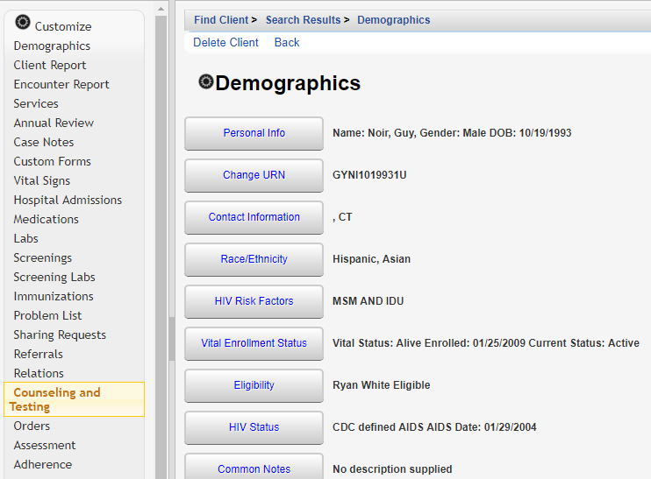

B. Bread Crumbs

C. Action bars

D. Links and link summaries

1. Main Menu

The top area with the HRSA logo, Provider name, Client Name, Client DOB, and Date of last service is the ***Title Bar***.

Above the title bar are your typical ***browser tabs***. Note that there are two open here (the blue arrows pointing at each ). One tab has my username, and the other shows the client record I just opened.

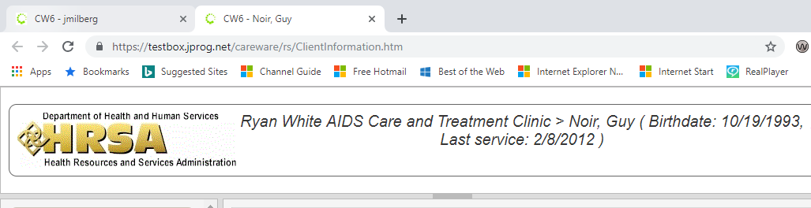

**Browser tabs**

One of the nice design features of a browser, as you are well aware, is that you can jump back and forth between tabs.

* You can open multiple clients at once. While this feature certainly adds some efficiency, say for data entry, it does potentially add some confusion: you will of course need to be certain you are in the right client record!! We are actually in the process of adding an additional unique symbol for each client so you will have more of a visual cue should you have multiple client records open at once.
* Take a moment to switch back and forth between these tabs to see how the screen view changes depending on what is open.

**Other ways to change how things appear on the screen:**

* Hold your mouse down on the bar(s) shown in the GREEN circle and drag it to make the left-hand menu bigger or smaller or similarly change the size of the title bar.
* To make the entire screen bigger or smaller, hold down the control key and move the roller on your mouse. You may already know this browser trick.
* Don’t forget the back and forth browser arrows in the red circle on the top left: if you accidentally (or not) select the left arrow, and jump out of CAREWare entirely, simply click the right arrow and you should return to where you were.
* **Screen refresh**: If for some reason the screen hangs and you are stuck, select **Ctrl + F5** to refresh the screen.
* Let’s open up the client’s **Personal** Info link.

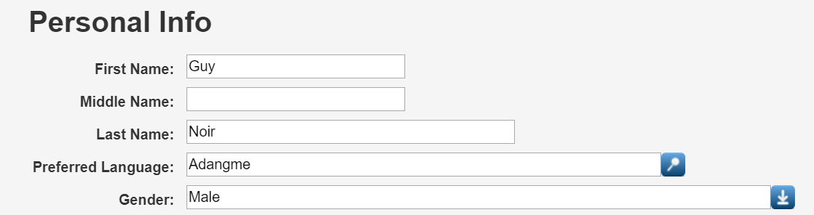

**Using drop down menus:**

Notice the **magnifying glass** to the right of the field “Preferred Language” and the **down arrow** to the right of the Gender field. You will see these throughout CAREWare 6:

* The **magnifying glass** indicates that there are more than ten items to choose from in the list. To find an item, you should start typing characters in the field. The CAREWare search facility is fast, so even if the list is long, it will rapidly return a list of potential selections that contains the characters you have started to type in. Of course the more characters you type in, the narrower the selection will be.
* If what you type in does not match an item on the list, you may see this warning message:  
    
  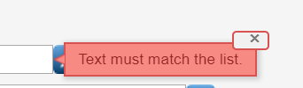
* You can click on the X to make the message disappear and continue your search
* For items like gender that have the **down arrow**, that simply means the list of choices is ten or fewer, as with this field:

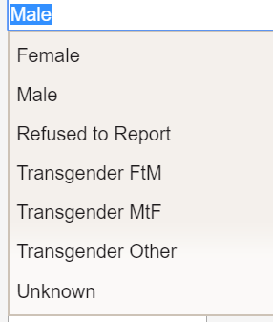

**Demographic Tab links**

Take a moment to review the links that are available in the **Demographics** tab. These should all be familiar. The only real difference in CAREWare 6 is that items that were previously all on one screen in CW 5 are now accessible in these separate links.

Important tabs: Remember, a client must be deemed eligible for RW services in order to get included in the RSR. Open the **Eligibility** tab in your client to see what the values look like. Of course, the **link summary** to the right of the tab shows the status as well.

* There are tabs to write notes **Common** to all providers on your network that also share this client, or notes specific to this **Provider**.

Let’s walk through some of the main menu items:

**Services**

* To Enter a **service** > Click **Add** > Enter the Service **Date** to get acquainted with the calendar. Enter a Service **Name**. Note the magnifying glass to the right of this field which means there are more than then ten services to choose from. Enter different values here to get used to the character search function.
* One you’ve entered your Service Name, click **Next** in the actions.
* On the next screen, select the Contract that pays for this service. Remember, if this service belonged to only one contract, that contract would already be selected.
* IMPORTANT NOTE: Notice that the “**Bread Crumbs**” on this screen are now not active hyperlinks. That is because you are in edit mode on this screen; CAREWare is expecting some data entry. If you simply clicked BACK, you’ll see those hyperlinks become active again.  
    
  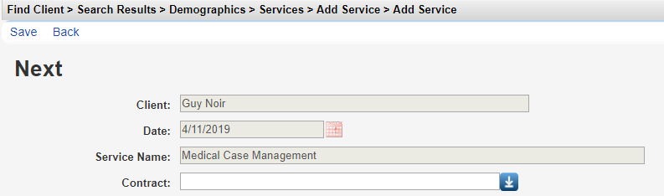
* All the other items below Contract are custom fields. They may or may not be required by your agency for each service entry.
* Now select Annual Review in the menu and take a look at the top 3 links:
  + **Annual Screenings –**update housing status
  + **Insurance Assessments –** update healthcare coverage information
  + **Poverty Level Assessments-** update household income and look at use of individual income for use in the new function to monitor “cap on charges.”
* **Continue down the Menu to look at the remaining important tabs**

**Add a new client**

Now that we’ve reviewed all the main client level tabs, return to the main menu and Add a client of your own, remembering to make it as unique as possible.

**Part II: Reports, Custom reports, and Performance Measures**

* **In the Main Menu** Select **Reports .**
* Now select the **Custom Reports link > Manage/Run Custom Reports**

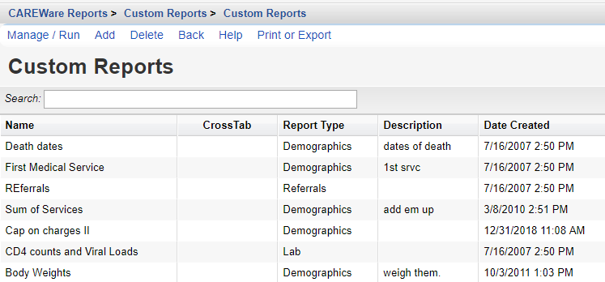



**A few important items to note on this screen:**

* Because the **Bread Crumbs** are active as hyperlinks, we could jump back directly to any of those screens.
* Use the space to the right of **Search:** to select any reports
* Sort the table by selecting any of the column headers
* On the bottom of the screen next to the **Rows** label, use the down arrow to select the number of reports to list onscreen (up to 20); use the right arrow to go to the next screen. \
* In the list of Actions, note the two on the right: Help and Print or Export. You will see similar action links throughout CW6, so let’s take a moment to examine them.

HELP! We’ve added Help links throughout CW6. The help screen in custom reports is very detailed.

**Print or Export**: Select this Action. Note the link options:

**Print current page/All pages/Current page as PDF/All pages as PDF**: Note that these opens up the report in a new tab in your browser

**Printable list format options**: Let’s you set title, head, and column fonts, size, other settings

Now let’s **Add** a new report.

* Remember to make the **Report Name** something unique to you so that it is indeed unique and will be easy for you to retrieve later.
* Let’s create a simple **demographic** custom report with client URN, age, gender, date of birth, and RW eligibility Status
* After we get that report to work, let’s add a **filter**. For example, restrict to females only.
* Once you get that filter to work, let’s add one more field. This one will be a more complicated “calculated field.” Calculated fields in CAREWare are very powerful but they require a little setting. Let’s take “**Last quantitative lab value**” and we’ll select each client’s last viral load.

And finally, let’s take a moment to look at the Performance measures module and the cap on charges functionality.