Quick user guide for CAREWare webinars
Nov 10 and Dec 1, 2020

- Client Eligibility and Contracts
- Remember for the RSR: To get included, a client must have an eligibility record that overlaps at least some time with the current reporting year.
- Along with not having a RWHAP-funded service in the period, lack of an eligibility record is one of the major reasons clients don’t get included in the RSR!

Note: In these screenshots, follow the “bread crumbs” in the top row to know exactly what screen is being shown.

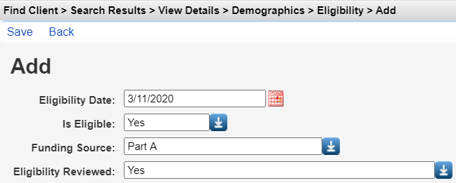

Report | RW Client Eligibility Record Required | Other Selection Criteria | Notes
EHE | - Yes: To get in RSR  - Not required for EHE report | - Any HIV positive client  - EHE Service RWHAP-funded
RSR | YES  (must overlap with report period) | - HIV Positive/indeterminate  - RWHAP-eligible Service within report period or  - HIV negatives in Part D program and linked to HIV Pos index client | Minimum build for 2020 RSR: #94
CDR | No | - Must have service funded by CARES Act contract | Can use custom filter to restrict further

- And remember that for a service to be considered for inclusion in the RSR, it must be in a contract that has RWHAP funding. It is easy to set contract funding sources (even after the services have been entered), as shown here:
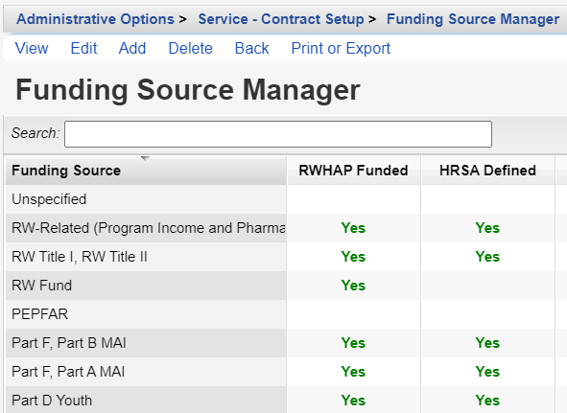

- EHE Report: Accessed From the main reports link:
- Set the year and Trimester of interest and then select Run
- Remember that all HIV positive clients with or without an eligibility record will be included.
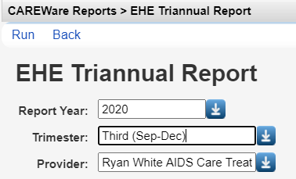

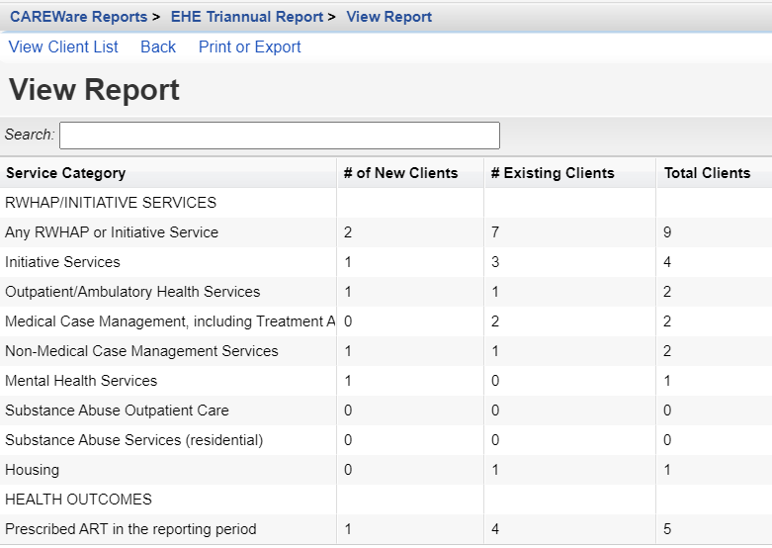

- Select a service category and then “View Client List” in the action bar to see which clients are being counted for this service. You can jump directly to the client’s record.

- COVID-19 Data Report (CDR): CARES Act
- Run a Financial Report and set the funding source filter properly
- You will need to have had a contract that has an identifiable CARES Act source of funding. Here we created a funding source called “COVID.”
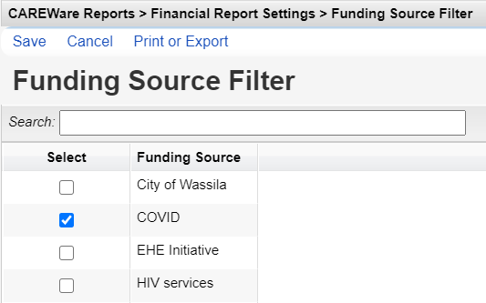

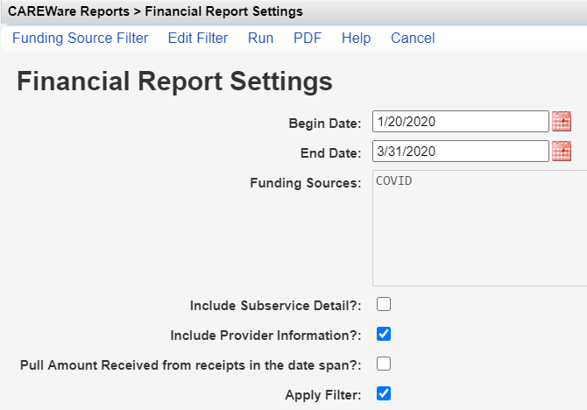
- Running the RSR
- To run the 2020 RSR, you’ll first need to install build 94 (or later)!
- As noted above, it’s always good to check that you’ve given an eligibility record to each client that should be included in the RSR.
- One quick way to generate a lookup list of clients that had a service in 2020 but lack an eligibility record is to create a performance measure to do this. For the denominator, use the field “Has RW funded Service in Span” and for the numerator try “Last eligibility field.” Set the criterion equal to “NULL” which is the same as missing.
- Run your RSR here as shown in the screen shot below
- The settings “Cross provider Labs (CD4 and viral load) and “Cross provider ART” allow you to grab values for those fields if any of your clients were seen at another provider and these data were entered at that location;
- Save the RSR output file to an easy to find location such as your desktop and give it an obvious name like “RSR for Provider X 10-30-2020”.
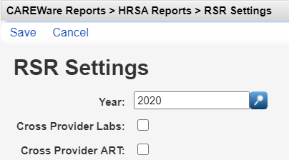
- Next, use the RSR viewer to review the counts for each field and, if helpful, go directly to specific clients and view their records.
- The RSR validation report will also help you isolate records that may have missing data.
- Both the viewer and validation are excellent ways to clean up your data before submitting your final RSR.
- When you are done cleaning everything up or filling in missing data (if needed), rerun the RSR (maybe rename the file so you know it is the final version and date); this is the XML file that you will upload to the HRSA website.

The example below shows a validation report with a few demographic values missing.
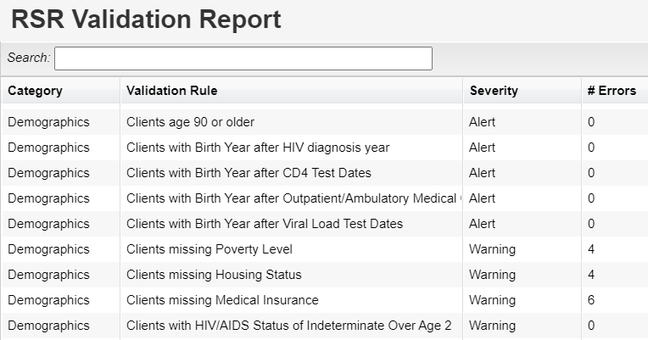
- Provider and Client Summaries
New to CAREWare are Provider and Client summary screens that allow you to graphically display performance measures (for Providers) and line graphs of quantitative labs (e.g. viral loads, CD4 counts, etc) for cients.
The setup for these summary screens is accessed from Central Administration.
The basic steps are as follows:
- For Provider summaries, create new or use existing performance measures: Performance measures are created or modified here: Reports > Performance Measures
- Create a summary group that will “house” the measures of interest; assign this group to the Provider(s) where you want these to appear. Provider summary groups are created here: Administrative Options > Custom Feature Setup > Provider Summary
- Create and configure the charts and their properties so they have the look you want (titles, colors, fonts) and select the chart types.
  - For provider level summaries you can select Bar or Pie Charts (e.g. showing the percent of all clients that are virally suppressed or with high cholesterol);
  - For client level summaries you can create longitudinal line graphs for any quantitative lab value such as viral load or CD4 count
- Create or modify Provider charts here:
If you have made any changes to your graphs/charts, or added new data and want to see the charts redrawn, go to this location (as shown in the breadcrumbs below), select the provider of interest, and then in the Action bar select “Recalculate.”

On the provider summary screen itself, below each chart, CAREWare will show the number of clients that are in and those that are not in the numerator. These also serve as hyperlinks to show actual lists of the clients themselves; you can jump straight to a specific individual whose record you want to examine.

Client Summary Setup
Basic steps to create a Client summary line graph:
- Create New Summary
- Give the summary a name
- In the form designer screen, Select “Add Control”
- First select “Add Line Graph for Quantitative Lab”.
- This next screen is where all the action is and where the primary properties of the graph are set. We’ll focus here on the main items. Here we’ll create a graph of the client’s viral load values in the last year.
  - Lab-type: The name of the quantitative lab that you are graphing, for example, the viral load.
  - Title-text: be explicit and clear here. For example, “Change in Viral load in last year”
  - Log-scale: For a viral load graph, CAREWare will default this field to “true,” meaning that the logarithm (base 10) of the viral load will be plotted, and not its raw value. The reason we use the log is because the viral load can have a very wide range in values, say from 0 (undetectable) to a million copies; the log values have a much narrower range. For example, at the beginning of treatment, the client may have a very high viral load such as 100,000 copies, and then in a few months drop to 100 copies. Those values are quite different, and they are difficult to plot on the graph. The log₁₀ of 100,000 is 5.0 and the log₁₀ of 100 is 2.0. So, we would plot the numbers 5 and 2. Just remember that the scale has changed!
  - For a lab test that has a normal distribution of values, like total cholesterol, you will of course not need to use the log-value.
  - X-axis-range: X is the horizontal axis and in all cases will be time in months. The default is 12.
  - Y-axis range: Leave the range to the default; CAREWare will take the log value of the viral load for you. For other plots you may want to change the range (that is, the min and max values shown on the vertical axis).
NOTE: You may need to scroll to the next page of this list to show the remaining properties available to you!
  - Line-size: This sets the thickness of the line that you are plotting. You may just need to play with this to see what looks best.
  - Line-color: As with the size, whatever looks best to you.
- Once you have set the control properties, go back to the main Form Designer screen. You should see a scrunched mock-up of your plot that looks like this! Simply drag the bottom right hand corner to resize your graph.
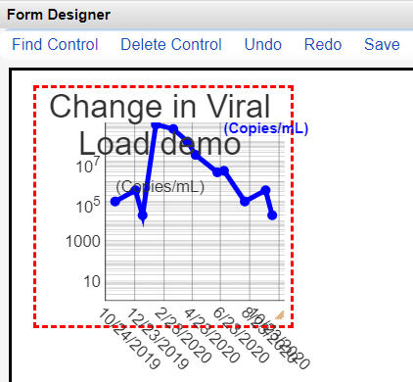

Our resized version looks like this:
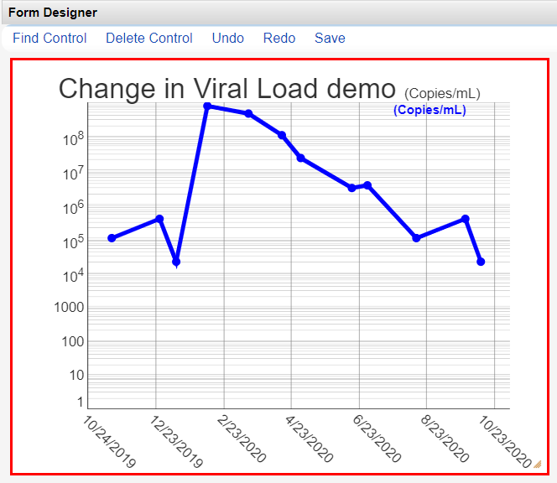
- To modify control properties of the larger form, select the outside border; it will highlight in solid red, as shown above. There are only two properties that can be modified here: the background color and size (which is typically done by simply resizing with your mouse).
- More importantly, to go back in and modify properties of the graph itself (e.g. change the title, or the ranges of the x or y axis, etc.), click on the graph and it will be highlighted with a dotted red line; select “Control Properties” on the main left-hand menu and you will see the main properties screen again.
- Don’t forget to always Save your form after you have made any changes!!
- Now it’s a good idea to log into a Provider domain, bring up a client with a few values and make sure that the plot meets your artistic (and scientific) standards….
- If you want to add other controls to the graph, in particular a demographic field, or a “doodad” such as a line or box or label, select the Add Control link to go back to the main control menu.
- Let’s add the client’s date of birth to the graph.
  - Select “Add Demographic Report Field”
  - Search for and select “Date of birth” in the list
  - Go back to the form designer screen and you’ll see your new control in a box on the top left. Move and resize as needed.
  - With this box still selected (it will be highlighted in red), select “Control Properties” from the left-hand menu. Now you can change properties of this control such as the font size, background color, border style, and font style.
  - Hit Save in the Action bar when you have finished.
  - The process is the same if you want to add a “Doodad”. For example, you may want to add a label to the box we just added so that it says “Date of Birth”, or place a horizontal line at the undetectable viral load level.
Here’s how our client summary line graph looks when we bring up a specific individual:
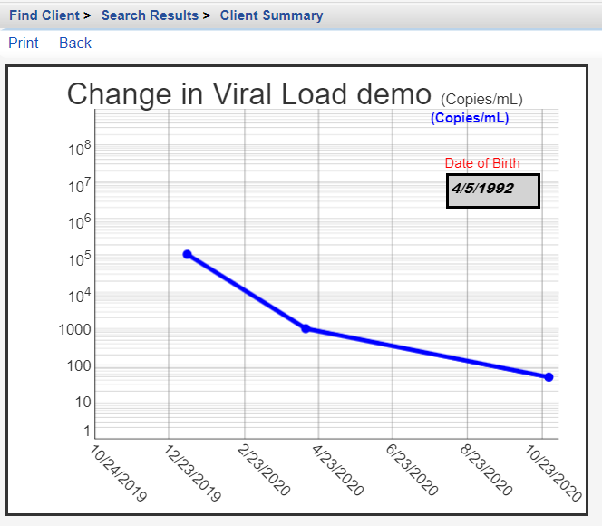

HIVQM Setup
The HIV quality management (HIVQM) program allows RWHAP recipients to run a group of performance measures and output the results in a simple CSV file (Excel) that is in the proper format for upload to the EHB HIVQM module.
The general process is to create or add existing measures to a group; Run that group of measures; and save the output as a CSV file.

- Create a group Name and choose “Select Performance Measures” as shown here:
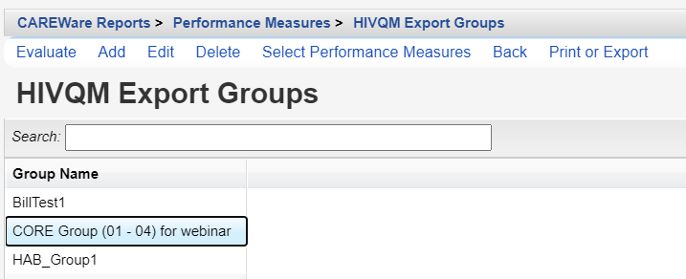

- Check the measures you would like to add to this group and hit Save.
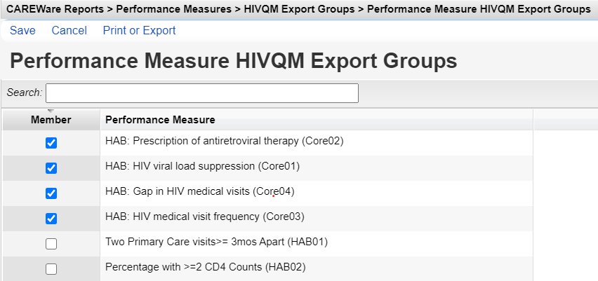
- Back on the main HIVQM Export Groups page, select your group and then hit Evaluate from the action bar.
- ON the next screen, change any of the settings, as needed. Don’t forget to select the “HIVQM Format” box on the bottom as this will ensure that you get your output in the right format.
Hyperlinks in the Action Bar allow you to quickly set the date range to the last year from today
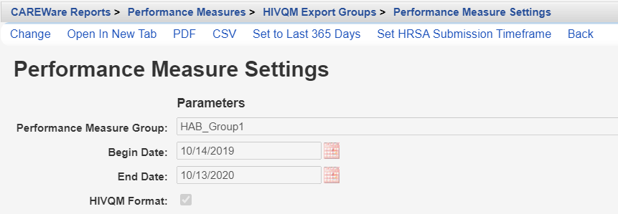
Selecting “Set HRSA Submission Timeframe” will bring up this screen where you will have to select the year and period:
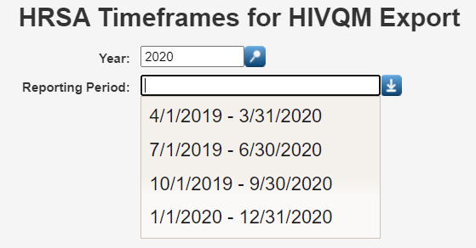

It might be a good idea to first output your measures in PDF so you can examine the results. NOTE: Depending on the number of measures being evaluated in your group, this could take some time to run!

When it looks good, run again but save as CSV. Download and save to an easy to find location. Your file will contain the following fields/coding for each measure in the group:

CSV Export file for HIVQM
Field No. | Field Name | Coding/Notes
1. | Provider ID | ID from RSR.  Entered in Admin Options > Provider setup> Additional Agency Information tab
2. | Provider Name | ID from RSR.  Entered in Admin Options > Provider setup>Agency information tab
3. | Software name | (defaults to CAREWare)
4. | Measure ID
5. | Measure Name
6. | Report start date
7. | Report end date
8. | Report creation date
9. | Records reviewed | Total clients with any service in the period
10. | Numerator | Count of clients
11. | Denominator | Count of clients
12. | Min Age | Minimum age if age range set
13. | Max Age | Max age
14. | Gender | 1=Male;  2=female;  3=Transgender(all);  4=Trans MtoF;  5=Trans FtoM  6=Trans unk  9=Unk
15. | Race/ethnicity | 1 = American Indian/Alaska Native  2 = Asian  3 = Black/Afr. American  4 = Hispanic /Latinx (any race)  5 = Nat Haw/Pac. Island  6 = White  7 = Multiracial
16. | HIV risk | 1 = Male to Male sexual contact (MSM)  2 = Injection drug use (IDU)  3 = MSM and IDU  4 = Heterosexual contact  5 = Perinatal transmission  6 = Other  9 = unknown

