UPMC PRESBYTERIAN SHADYSIDE
HIV/AIDS PROGRAM

GUIDELINE ID#: 32
CATEGORY: Clinical

GUIDELINE SUBJECT: PACT Food Assistance

- GUIDELINE PURPOSE

To provide additional food assistance in conjunction with other government and local food resources, to patients defined as food insecure. To promote healthy eating and lifestyle changes and educate patients about healthy eating on a budget.

Food insecurity can directly affect a patient’s health status and should be considered in a patient’s plan of care. Without stable access to healthy and nutritious food items, patients may experience any of the following: malnutrition, unintentional weight loss, delayed wound healing, and poor management of nutrition-related comorbidities such as diabetes, hyperlipidemia and hypertension.

- SCOPE

This document outlines the policy and procedure for providing food assistance to PACT patients identified as “food insecure.”

- PROCEDURES
  - PACT patients must be referred to the Registered Dietician Nutritionist (RDN) to determine if they qualify as food insecure. Patients can self-refer or be referred by any member of the health care team.
  - A patient must meet the following requirements to be eligible for PACT’s Food Assistance Program:
- Complete Food Insecurity Screen
  - Appendix A
- Meet Income Requirements
  - Appendix B
- SNAP Benefits
  - Patient must be active or in process of signing up for SNAP benefits
  - New Food Assistance Appointment: During the initial appointment, the RDN will administer the food insecurity screen and determine if the patient qualifies for PACT food assistance. If the patient qualifies and agrees to the program Guidelines, they will receive an ALDI Food Market gift card ($25.00 Households of 1-2 people) or ($50.00 Households of 3 or more). During this appointment, the patient will receive information about eating healthy on a budget, stretching dollars, using left-overs, nutrition and medical diagnoses. Information regarding community food resources and assistance with applications for these resources will also be provided.

  - Program Guidelines: Program guidelines will be explained by the RDN at the initial appointment. If a patient wishes to participate in the program, they will be asked to read and sign an agreement outlining the following:

    - Gift Cards: To receive subsequent gift cards, patients must bring the receipt from the purchase made with the previous gift card. This receipt will document that food was purchased and can also be used for healthy eating discussion. Receipts will be kept on file by RDN. If a patient fails to bring in a receipt from the previous gift card purchase, they will have one additional opportunity. If they fail to bring a receipt a second time, they will not receive a gift card at that appointment.

    - Continuing Eligibility: To remain eligible for the program, patients must continue to meet the above requirements.
In addition, they must agree to the following:
      - Return gift card receipts prior to receiving another gift card
    - One strike policy: Patient may misplace receipt one time and continue to participate in program
    - Receipts can be returned in original form or scanned and emailed.
      - Complete MD follow-up visit at least once every 6 months for routine HIV care
      - Complete formal nutrition assessment at least once every 6 months

    - Additional Program Guidelines:
- Gift cards must be used to purchase healthy/nutritious food items
  - Patients are provided a list of healthy food items and non-healthy/ “junk food” items at initial visit for guidance
  - If a patient purchases unhealthy food items, they will be engaged in nutrition education on healthier options/ “swaps”
  - Non-food items are not allowed
    - If a patient is in need of non-food items, they can be referred to Social Work for PACT’s hygiene closet
- Walk-in food assistance appointments are highly discouraged; patients are asked to call ahead to schedule follow up visits with RDN
  - Patients that present for walk-ins will be seen if RDN has appointments available
  - Walk-in patients are informed they may have a wait based upon scheduled visits for that day
- Patients must present to clinic to pick up gift cards (no monthly mailing)
  - Part of program is engagement in nutrition education
  - Promotes retention in care at the clinic
  - Exceptions made at discretion of RDN
- Past and future months
  - Once a month has passed, opportunity to receive a gift card for that month has been missed (no “backtracking”)
  - Patients may receive gift cards in advance per discretion of RDN

SIGNED:
Deborah McMahon, MD Signature______________________ Date_______
Clinical Director

Paula Ziemski, CPC, PHR, SHRM-CP Signature______________________ Date_______
Administrative Director

ORIGINAL: April 2019
REVIEWED:

APPENDIX A - Two-question screen adopted from the USDA U.S. Adult Food Security Survey Module³

Directions to read to patient: I’m going to read you two statements that people have made about their food situation. For each statement, please tell me whether the statement was often true, sometimes true, or never true for your household in the last 12 months.
1. “We worried whether our food would run out before we got money to buy more.” Was that often true, sometimes true, or never true for your household in the last 12 months?
2. “The food that we bought just didn’t last and we didn’t have money to get more.” Was that often, sometimes, or never true for your household in the last 12 months?

Grading:
A response of “often true” or “sometimes true” to either question is indicative of food insecurity.

APPENDIX B⁴ - Income Requirements

At or below 130% of the Federal Poverty Level in PA (2019)

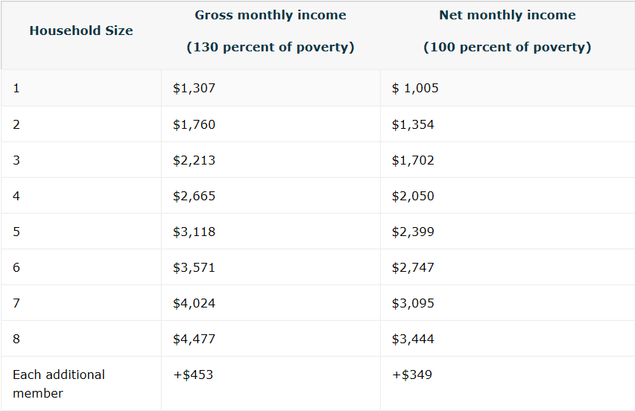

APPENDIX C – Resources

¹ https://www.healthypeople.gov/2020/topics-objectives/topic/social-determinants-health/interventions-resources/food-insecurity

² https://www.ers.usda.gov/topics/food-nutrition-assistance/food-security-in-the-us/key-statistics-graphics.aspx#foodsecure

³https://www.ers.usda.gov/media/8279/ad2012.pdf

⁴https://www.fns.usda.gov/snap/income-eligibility-standards

