INSTRUCTIONS FOR COMPLETING AND SUBMITTING THE
FINAL FY 2022 RYAN WHITE HIV/AIDS PROGRAM (RWHAP) PART A
ANNUAL PROGRESS REPORT

GENERAL INSTRUCTIONS
The RWHAP Part A Progress Report is made up of the following components:

- Programmatic Narrative
  - Program Successes and Challenges
  - Planning Council/Body Activities
  - Early Identification of Individuals with HIV/AIDS (EIIHA) Update
  - Subpopulations of Focus Update
- Final FY 2022 Service Category and HIV Care Continuum Services Tables
- Certification of Aggregate Administrative Expenditures
- FY 2022 Women, Infants, Children and Youth (WICY) Expenditures Report

To ensure that progress reports are fully responsive to the areas outlined above, recipients are asked to format narrative sections using the categories and numbering as they appear below.

- Programmatic Narrative
  - Program Successes and Challenges
    - Discuss at least three program accomplishments and at least three program challenges addressing the National HIV/AIDS Strategy goals, relating to activities implemented based on the FY 2022 RWHAP Part A competitive application (HRSA 22-018). Discuss how challenges were addressed.

    - As applicable, explain how the following factors have impacted the HIV care continuum outcomes for people with HIV in your jurisdiction:
      - Expanded/reduced resources;
      - Unmet need;
      - Public health emergencies (e.g., COVID-19, mpox) and/or natural disasters;
      - Evolving healthcare landscape (e.g., changes in health care coverage options)

    - Please describe how you share HIV care continuum outcome information with community stakeholders.

  - Planning Council/Body Activities
    - Planning Council/Body Accomplishments - Discuss at least three planning council/body accomplishments during the reporting period (March 1, 2022, through February 28, 2023) that impacted the provision of services resulting in improved outcomes on the HIV care continuum (e.g., allocated funds to outreach services for the first time resulting in the reengagement of 30 clients into care).

    - Planning Council/Body Challenges - Discuss at least three challenges faced by the planning council/body during the reporting period (March 1, 2022, through February 28, 2023) that impeded improvements in HIV care continuum outcome targets (e.g., 1) Planning council/body did not create allocation options to quickly address changes in the final award, or 2) a lack of a rapid reallocation process, which resulted in the inability of the recipient to expend unused funds for needed telehealth services during the last quarter of the grant year).
      - For each challenge identified, include a brief discussion of the following:
        - Describe the challenge;
        - Discuss the plan developed to overcome the challenge; and
        - Provide implementation updates to overcome the challenge.

    - Discuss any issues and challenges related to compliance with planning council/body legislative requirements (e.g., reflectiveness and representation, needs assessment, priority setting and resource allocation, etc.) and steps taken to address the challenges.

  - Early Identification of Individuals with HIV/AIDS (EIIHA) Update
The goals of the EIIHA plan are to present a strategy for: (1) identifying individuals with HIV who do not know their HIV status; (2) making such individuals aware of their status and enabling them to use the health and support services; and (3) reducing barriers to routine testing and disparities in access and services among affected subpopulations and historically underserved communities.

    - Outline the EIIHA activities that were successfully implemented. Describe the following:
      - Specific activity outcomes and what was done to achieve them;
      - Resources and partnerships used (both internal and external to the program);
      - Barriers and/or challenges to achieving the specific successful outcomes; and
      - Overall FY 2022 EIIHA activities contributed to the National HIV/AIDS Strategy goals.

    - For the EIIHA activities that were unsuccessfully implemented, describe the following:
      - Barriers and/or challenges; and
      - Alternative approaches to achieve more favorable outcomes.

    - Since your FY 2022 competitive application submission, describe any efforts undertaken to remove legal barriers to increasing access to care, including state/local laws and regulations. Clearly state “None” if no efforts have been undertaken.

    - Describe how the EIIHA plan and outcomes were shared with the HIV stakeholder community (e.g., presentations at conferences, journal articles, presentations to planning council/body, etc.).
  - Subpopulations of Focus Update
Subpopulations of focus are specific groups of people with HIV within RWHAP Part A jurisdictions that are disproportionately affected by HIV, as a result of specific needs. Per your most recent competitive application, subpopulations of focus were identified for the three-year period of performance.

Similar to other components of the RWHAP, the goal of the Minority AIDS Initiative (MAI) is improved health outcomes among people with HIV who are racial and ethnic minorities as demonstrated by viral suppression. MAI funds must be used to deliver services designed to address the unique barriers and challenges faced by hard-to-reach, disproportionately impacted individuals within the Eligible Metropolitan Area (EMA)/Transitional Grant Area (TGA).

    - Provide viral suppression rates for the three subpopulations of focus identified with a narrative describing any improvement in outcomes. Indicate the data source. The data source must remain the same for the three-year period of performance.
    - Describe how MAI services implemented in FY 2022 address the needs of the three subpopulations of focus identified.
    - Describe any challenges meeting the needs of the subpopulations of focus and how these challenges were addressed.

- Final FY 2022 Service Category Plan Table and HIV Care Continuum Services Table
The Service Category Plan Table template has been updated to a multi-year table to collect trend data from the three-year period of performance. Recipients should report data on the same template each year with the previous fiscal year sections completed.
  - Submit an updated version of your FY 2022 Service Category Plan Table showing expended amount, unduplicated clients, and service units on the Service Category Plan Table and HIV Care Continuum Services Table for the reporting period (March 1, 2022, through February 28, 2023), with estimates submitted in the FY 2022 Program Submission.
    - On the Service Category Plan Table, provide a summarized analysis explaining any variance that exceeds 20% (over or under) in the comments tab located in the Excel workbook. Variances for expended amount, unduplicated clients, and service units will automatically populate based on data entered on the spreadsheet template provided. Comments to address variances that exceed 20% (over or under) must address why the variance occurred and the impact on other variances.
Note: The Average Cost per Service Unit column will automatically populate based on the expended amount and service units entered on the spreadsheet template provided. This column will assist in determining reasonableness of the average cost per service unit and inform future program planning activities.
  - Submit an updated version of the diagnosis-based FY 2022 HIV Care Continuum Services Table showing actual outcomes.
Instructions: Using CDC HIV Care Continuum definitions and appropriate baseline surveillance data, develop a diagnosis-based HIV Care Continuum Services Table. Data source should remain the same for each year in the 3-year grant cycle. You must include baseline and target indicators as a numerator and denominator, as well as a percentage for each step. List the service categories funded by RWHAP Part A that were funded to achieve the outcomes during the FY 2022 budget period.

Regardless of the format used for the HIV Care Continuum Table, use the provided CDC definitions for each step of the diagnosis-based HIV care continuum when calculating the numerator and denominator.

Important notes:
Please note the following elements of the HIV Care Continuum Services table to ensure an improved data input:

- Required field to indicate the surveillance data source, which must be the same as the accepted FY 22 Program Submission.
- A formula in the spreadsheet auto-calculates the numerator and denominator percentage column.
- A “Percentage Change from Baseline to Actual” cell was added, which calculates automatically.
- [Any bracketed red text indicates an input field]
- Please refer to attached HIV Care Continuum Services Table template and sample screenshot.

Steps to complete and submit the FY 2022 HIV Care Continuum Table:

Indicate Data Source and [input] on row 3 of the Diagnosis Based HIV Care Continuum Services Table. Data source should remain the same for each year in the 3-year grant cycle. The data source must be the same as the accepted FY 22 Program Submission. Client level data are not an acceptable source of surveillance data.

[Input] Numerator and Denominator Baseline numbers on rows 8,15, 22, 29 & 36 for the respective goals. The percentage will calculate automatically. Use the percentages as a data entry check to ensure it matches the source data.

For the Actual [Input] Numerator and Denominator numbers on rows 10, 17, 24, 31, & 38.

Percentage Change from Baseline to Actual calculates automatically. A reasonable and attainable increase falls between 1-6%. For values of less than 1% and greater than 6% in any stage provide comments in [input explanation].

The RWHAP service categories related to each stage of the HIV care continuum must be reflected in the service category column of the table; list funded service categories that will contribute to achieving the targets described in the outcome. The [input] should tie to categories listed on the Part A Service Category Tab and/or MAI Service Category Table.

HIV Care Continuum Services Table – Sample Screenshot
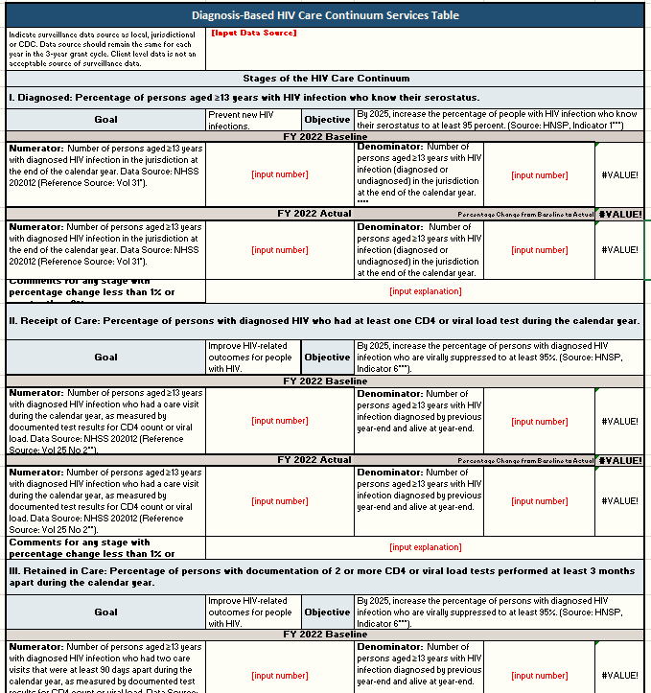

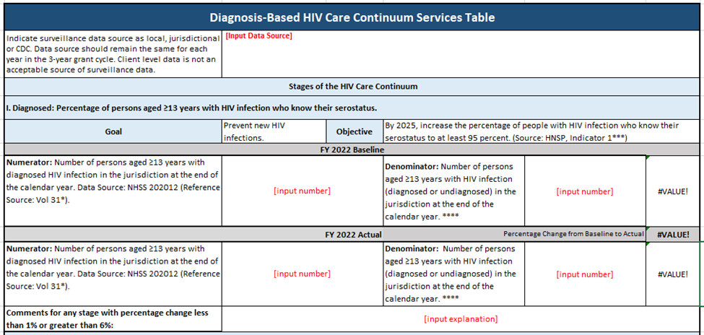
Comments for any stage with percentage change
Change from Target to Actual
Data Source

- Certification of Aggregate Administrative Expenditures
The recipient is required to certify the actual amount of funds expended on administrative costs by subrecipients does not exceed 10% of the Aggregate Total of All HIV Service Dollars Expended.
To complete the form, use the following instructions:
- The Aggregate Total of All HIV Service Dollars Expended is reported on the “Total Service Expenditures” Line in the FY22 Part A and MAI Expenditure Report.
- The Available Aggregate Administrative Expenditures amount is calculated by multiplying the Aggregate Total of All HIV Service Awards Expended by 10%.
- The Actual Aggregate Administrative Expenditures amount is reported by the recipient and is based on administrative expenditures reported by their subrecipients.
- To calculate the Actual Aggregate Administrative Expenditure Percentage, divide the Actual Aggregate Administrative Expenditures by the Aggregate Total of All HIV Service Dollars Expended and multiply by 100.
The financial officer responsible for the RWHAP Part A funds must sign the certification indicating that the Aggregate Administrative Expenditures is under the 10% cap (See Appendix 1).

- FY 2022 Women, Infants, Children and Youth (WICY) Report
Part A of Title XXVI of the Public Health Service Act, as amended by the Ryan White HIV/AIDS Treatment Modernization Extension Act of 2009, requires RWHAP Part A recipients to use a proportionate amount of their grant dollars to provide services to women, infants, children, and youth (WICY) with HIV/AIDS.

Recipients may use the RWHAP Part A FY 2022 WICY Report workbook template provided to report these expenditures. Use the CY 2021 CDC WICY percent data (a tab on the WICY Report Workbook) to prepare your EMA/TGA’s report of WICY expenditures for FY 2022.

For further guidance on preparing your WICY report, please use the instructions tab on the WICY Report workbook. These guidelines were prepared by the Health Resources and Services Administration HIV/AIDS Bureau to assist RWHAP Part A recipients with continued implementation of the WICY requirement and the preparation of required annual WICY Reports.

Appendix 1

RYAN WHITE HIV/AIDS PROGRAM PART A
FINAL CERTIFICATION OF AGGREGATE ADMINISTRATIVE EXPENDITURES
REPORTING PERIOD - March 1, 2022 – February 28, 2023
RECIPIENT | [Enter Recipient Name]
GRANT NUMBER | H89HAXXXX
AGGREGATE TOTAL OF ALL HIV SERVICE DOLLARS EXPENDED | $
AVAILABLE AGGREGATE ADMIN EXPENDITURES | $
ACTUAL AGGREGATE ADMINISTRATIVE EXPENDITURES | $
ACTUAL AGGREGATE ADMIN EXPENDITURE PERCENTAGE | %
I certify to the best of my knowledge and belief that the report is true, complete, and accurate, and the expenditures, disbursements and cash receipts were for the purposes and objectives set forth in the terms and conditions of the Federal award. I am aware that any false, fictitious, or fraudulent information, or the omission of any material fact, may subject me to criminal, civil or administrative penalties for fraud, false statements, false claims or otherwise. (U.S. Code Title 18, Section 1001 and Title 31, Sections 3729-3730 and 3801-3812)
Print Name of Financial Officer: |  | Date:
Signature of Financial Officer:

