Ryan White HIV/AIDS Program Part A
FY 2023 Program Submission Instructions

Ryan White HIV/AIDS Program (RWHAP) Part A Recipient:
The Program Submission is a single submission that all recipients must submit as a requirement for their Fiscal Year (FY) 2023 RWHAP Part A award. The report must be submitted in the HRSA Electronic Handbooks (EHBs) system under the appropriate placeholder. The Program Submission must include the following components:
- A signed letter from Planning Council (PC) or Planning Body (PB) Chair(s) endorsing priorities and allocations, including a signed copy of the RWHAP Part A & Minority AIDS Initiative (MAI) Planned Allocations Table
- Planning Council/Planning Body Membership Roster and Reflectiveness Worksheet
- Clinical Quality Management (CQM) Plan
- RWHAP Part A and MAI Service Category Plan Table
- HIV Care Continuum Services Table
If you require assistance or have questions about the Program Submission, please contact your Division of Metropolitan HIV/AIDS Programs (DMHAP) project officer.
Program Submission Requirements
Section 1: A signed letter from Planning Council (PC) or Planning Body (PB) Chair(s) endorsing priorities and allocations, including a signed copy of the FY 2023 Ryan White HIV/AIDS Part A & MAI Planned Allocations Table
- The letter must indicate that all RWHAP HIV core medical and support services were prioritized during the annual priority setting and resource allocation (PSRA) and that the Planning Council (PC) or Planning Body (PB) concurs with the funded service categories and the dollar amount as reflected in the FY 2023 RWHAP Part A and MAI Allocations Table.

- Include a signed copy of the RWHAP Part A and MAI Planned Allocations Table that has been printed from the Grantee Contract Management System (GCMS) and approved by the PC or PB during the PSRA process. Electronic signatures are acceptable.

Section 2: Planning Council/Planning Body Membership Roster and Reflectiveness

A suggested template has been developed for information that must be submitted for the Planning Council (PC)/Planning body (PB) membership roster, and the representation and reflectiveness requirement. In this template, there are four worksheets: Instructions, PC/PB Membership Category Tool, PC/PB Roster, and the PC/PB Reflectiveness Table.
The Instructions worksheet provides directions on how to complete the PC/PB Membership Category Tool, PC/PB Roster and PC/PB Reflectiveness Table.
The PC/PB Membership Category Tool is used to help identify legislatively required PC/PB membership categories that have not been met and to describe plans that have been developed to meet the requirement. On the tool, indicate whether the membership categories are vacant. If there are any vacancies, indicate the length of the vacancy, whether there are any barriers for recruitment and describe the plan developed to ensure this vacancy is filled.
For the PC/PB Membership Roster worksheet, respond to the questions and note that formulas are embedded in the template. Information must identify term limits and membership rotations, e.g., members serve three, two-year terms. Describe the plan for establishing term limits in the comments sections, if term limits have not been established. If the PC/PB has a required membership vacancy provide a detailed and succinct narrative documenting efforts and plans to fill the category vacancy along with the Chief Elected Official (CEO) or designee signature.
The PC/PB Reflectiveness Table worksheet is meant to capture the PC/PB composition as it relates to the Eligible Metropolitan Area/Transitional Grant area’s (EMA/TGA) prevalence data. Reflectiveness must be based on the most recent prevalence of HIV disease (AIDS prevalence plus HIV prevalence, actual or estimated) data in your EMA/TGA. If the jurisdiction did not meet the reflectiveness requirement for total members of the PC/PB members or unaffiliated clients on the PC/PB, describe the plan that has been developed to ensure the reflectiveness requirement will be met.
Section 3: Clinical Quality Management Plan

The CQM plan should describe all aspects of your CQM program including infrastructure, priorities, performance measures, quality improvement activities, action plan with a timeline and responsible parties, and evaluation of the CQM program. For more information on the expectations of the CQM Plan, review the Dear Colleague Letter and Clinical Quality Management Policy Clarification Notice #15-02.
Section 4: Service Category Plan Table

Provide a Service Category Plan in table format, as described below, that utilizes core medical and support service categories as prioritized and funded by the Planning Council/Planning Body (PC/PB) or through local community planning processes. A suggested template has been provided to aid in the completion of this submission component. The plan should consist of both Ryan White HIV/AIDS Program (RWHAP) Part A and Minority AIDS Initiative (MAI) funds.

The Service Category Plan Table template has been updated to a multi-year table to collect trend data from the three-year period of performance. Recipients should report data on the same template each year with the previous fiscal year sections completed.

Indicate if you have an approved core medical services waiver for the FY 2023 budget period. If you did not submit a core medical services waiver for the FY 2023 budget period, the allocations must align with the 75 percent core medical services requirement. The Service Category Plan Table must also align with the budget and budget narrative sections of the Non-Competing Continuation Progress Report.

The Service Category Plan Table illustrates how you fund RWHAP Part A and MAI core medical and support services in the EMA/TGA. It is comprised of service categories, priority numbers as directed by the PC or recommended by the PB, funding amounts, unduplicated clients, service unit definitions, number of service units, and MAI subpopulations of focus (MAI service category table only). For every service category funded by RWHAP Part A in the jurisdiction, provide the following in table format:

- RWHAP Part A
  - FY 2022 Actual budget period RWHAP Part A service categories with priority numbers, expended amounts, number of unduplicated clients served, service unit definitions, and number of service units provided. Include total dollar amounts for core medical services, support services, a total of the combined core medical and support services. The percentage of expenditures for RWHAP Part A core medical and RWHAP Part A support services will automatically calculate.

  - FY 2023 Estimated budget period RWHAP Part A service categories with priority numbers, estimated funding amounts, projected number of unduplicated clients to be served, service unit definitions, and projected number of service units. Include total dollar amounts for core medical services, support services, a total of the combined core medical and support services. The percentage of allocations for RWHAP Part A core medical and support services will automatically calculate.

Note: The Average Cost per Service Unit column will automatically populate based on the estimated amount and service units entered on the spreadsheet template provided. This column will assist in determining reasonableness of the average cost per service unit and inform future program planning activities.

- MAI
  - FY 2022 Actual budget period MAI service categories with priority numbers, expended amounts, number of unduplicated clients served, service unit definitions, number of service units provided, and for each MAI funded service, indicate which subpopulation(s) of focus were served. Include total dollar amounts for core medical services, support services, a total of the combined core medical and support services. The percentage of expenditures for MAI core medical and MAI support services will automatically calculate.

  - FY 2023 Estimated budget period MAI service categories with priority numbers, estimated funding amounts, projected number of unduplicated clients to be served, service unit definitions, projected number of service units, and for each projected MAI service, indicate which applicable subpopulation(s) of focus is anticipated to be served. Include total dollar amounts for core medical services, support services, a total of the combined core medical and support services. The percentage of allocations for MAI core medical and MAI support services will automatically calculate.

Note: The Average Cost per Service Unit column will automatically populate based on the estimated amount and service units entered on the spreadsheet template provided. This column will assist in determining reasonableness of the average cost per service unit and inform future program planning activities.

Section 5: HIV Care Continuum Services Table

Using CDC HIV Care Continuum definitions and appropriate baseline surveillance data, develop a diagnosis-based HIV Care Continuum Services Table. Data source should remain the same for each year in the 3-year grant cycle. You must include baseline and target indicators as a numerator and denominator, as well as a percentage for each step. List the service categories funded by RWHAP Part A that will aid in achieving the desired target outcomes to be achieved during the FY 2023 budget period (one year).

Regardless of the format used for the HIV Care Continuum Table, use the provided CDC definitions for each step of the diagnosis-based HIV care continuum when calculating the numerator and denominator.

Steps to complete and submit the FY 2023 HIV Care Continuum Table:

Indicate Data Source and [input] on row 3 of the Diagnosis Based HIV Care Continuum Services Table.

For the Baseline of surveillance data, [input calendar year] on rows 7, 14, 21, 28 & 35.
[Input] Numerator and Denominator Baseline numbers on rows 8, 15, 22, 29 & 36 for the respective goals. The percentage will calculate automatically. Use the percentages as a data entry check to ensure it matches the source data.

For the Target [Input] Numerator and Denominator numbers on rows 10, 17, 24, 31, & 38.

Percentage Change from Baseline to Target calculates automatically. The goal should be reasonable and attainable within one year. Use this as a validation check. The value should not be flat. A reasonable and attainable increase falls between 1-6%. For values of less than 1% and greater than 6% in any stage provide comments in [input explanation] located at the bottom of the table

The RWHAP service categories related to each stage of the HIV care continuum must be included in the service category column of the table; list funded service categories that will contribute to achieving the targets described in the outcome. The [input] should tie to categories listed on the Part A Service Category Tab and/or MAI Service Category Table.

HIV Care Continuum Services Table – Sample Screenshot

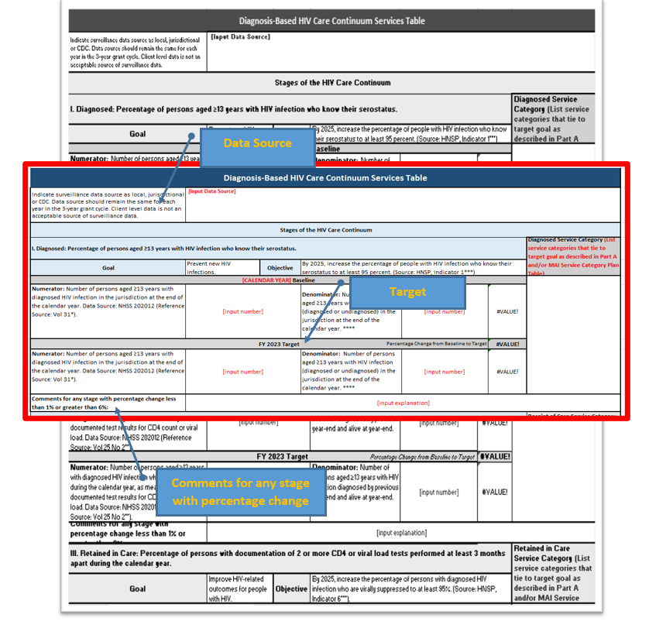

In FY 2021 applications, recipients indicated which MAI services were provided to identified priority populations in the 2021 budget period. In FY 2022 applications, recipients identified which applicable subpopulations of focus, as outlined in the Demonstrated Need section, will receive MAI services beginning in the FY 2022 budget period.

