HAB (HIV/AIDS Bureau)
Health Resources and Services Administration

SPNS/IHIP Webinar Series (4 of 4)
7/17/2019

Tinsley, Melinda (HRSA)

Submitted by:Matthews, Jovaun (HRSA) [C], Adobe Connect Team

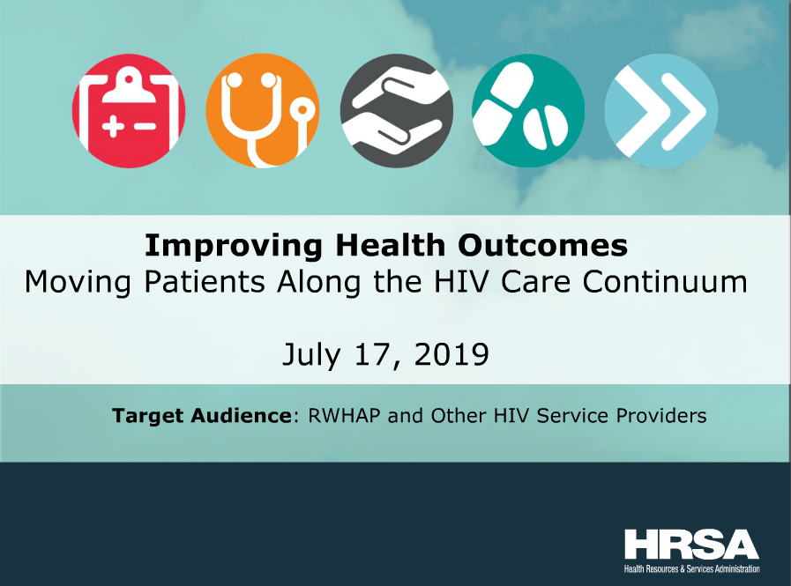

Event: SPNS/IHIP Webinar Series (4 of 4)
Date: 7/17/2019
Event Coordinator: Tinsley, Melinda (HRSA)
Adobe Connect License: Meeting (<100 participants)
Unique Users: 24 Unique Users
Audio: Universal Voice/ Conference Bridge
Start and End Time: 1:30pm-3:00pm
Duration: 90 Minutes
URL: https://hrsa.connectsolutions.com/spnsihip/
Problems Encountered with Adobe Connect Pro
No Problems Encountered

Recording
https://hrsa.connectsolutions.com/p3ds25ci3t5g/

Attendees
Abenai Sanders
Alison
Andrea Norberg (AETC NCRC)
Anthony J Santella
Brad Brockmann
Captioner
chantal
Cheryl betteridge
Courtney Elrod
Ella Vanderbilt-Fried
Emily Julian
gerald
Jill
Jovaun Matthews
Justin Chan
Melinda Tinsley
Noelle M. Weeks
Paul Meissner
S. Julian
Sarah Cook-Raymond
Shelly Kowalczyk
Stephine Polk
Tim Emanzi
Ugochi Chinemere

Chat History
N/A

Polls

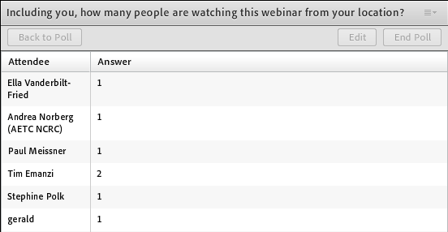

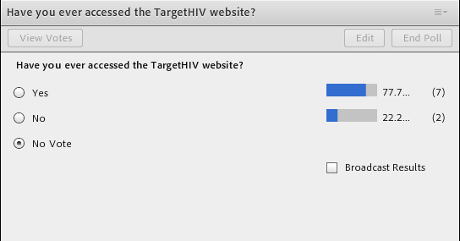
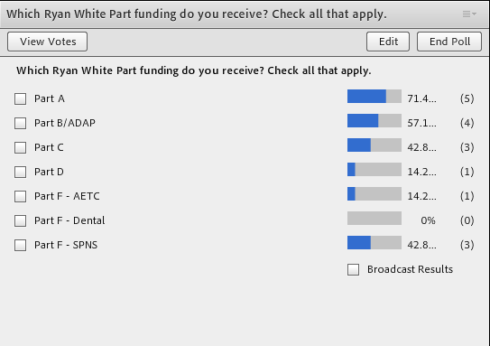
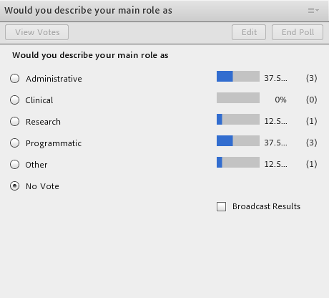
Q&A

Q/A Done Over the Phone

Transcript

Please stand by for real-time captions.
>> Please continue to hold for today's conference call to begin. We are currently awaiting for the speakers to join the conference call. Again please continue to standby for today's conference call. Thank you.
>> Welcome and thank you for standing by for the SPNS/IHIP webinar conference call. I would like to inform all parties that the lines have been placed in a listen only mode until the question and answer session of today's conference. I would now like to turn the call over to Shelley, thank you you may begin.
>> Thank you. Hello, everyone my name is Shelly Kowalczyk and I be moderating today's call on Improving Health Outcomes, Moving Patients Along the HIV Care Continuum . This is our final webinar in our series brought to you by the HRSA Special Projects of National Significance . Just a few housekeeping rules before we get started. Right now we have some brief polling questions on the screen and if you have not already, please go ahead and complete those. There are two ways to listen to the webinar today. We have the dial-in information on the screen with a number and the pass code or you can enable your computer audio and listen to your speakers. This webinar is being recorded and will be available for viewing on the target HIV website with about 304 weeks telling the webinar. As the operator mentioned, all phones are in listen only mode so we will hold questions until the end of the webinar. However you will see there is a checkbox feature that you can use to enter questions at any time, which we will address at the end during the Q&A period and then you will also be able to verbally communicate your question when the operator opens up the line at the end. And then finally at the end of the webinar we will provide a link to a brief online form to collector feedback on today's presentation. We greatly appreciate it if you could take a minute to complete that. We will also send the link to the form by email to any folks who registered for the webinar.
>> We will go ahead and get started by removing the polling questions from the screen, please. Okay. Today I will provide a very brief overview about the Special Projects of National Significance or the SPNS program and integrating HIV practices for IHIP program we will hear from our speaker from 19 from worker hut -- Alison Jordan [Indiscernible - low volume] she has been nationally recognized public health professional with more than 20 years of senior government and health system management experience including 15 years designing and developing reentry and continuity services for New York the correctional services. She overseas activities and coordinating medical discharge planning and providing education, services and linkages to community care after incarceration in New York City jails. Allison has extensive expense working with underserved experiences communities [Indiscernible - low volume] incarceration and designing and implementing large-scale culturally sensitive direct service healthcare programs. She received her Masters degree in social work from the city University of New York, and her College school of social work. Once again we will open up the lights and take questions following Alison presentation.
>> Date SPNS program is funded through the Ryan White HIV program and provides opportunity for developing implementing and assessing a patient's design for the [Indiscernible - low volume] and address emerging issues in HIV care and populations most affected by HIV. In order to most effectively promote dissemination and replication of successful SPNS models this SPNS model integrated [Indiscernible - static] or the IHIP project. Through the IHIP project SPNS effectively promotes markets and disseminates strategies to support optimal implementation of these models. So these strategies include developing tools and resources such as implementation manuals, intervention guides and fact sheets that are use to encourage replication in these models. And agent stakeholders to increase reach of these tools and resources. Supporting peer to peer sharing of information through the provision of quality building assistance and then disseminating information via e-news letter to market and promote tools and upcoming webinars.
>> So at this point I'm going to turn things over to Alison for her presentation, Alison ?
>> Thank you so much, Shelly Kowalczyk and I see some new names on the screen there and looking forward to having a bit of a conversation as we go through this and we will take questions at the end. A big thank you to Jaclyn Casado who is the instigator supreme of most of this work. And generous amount who helped us count for the workforce initiative to help [Indiscernible - low volume] help comes also for cost-cutting analysis, carbon host may who oversaw the one-stop curve centers component of this initiative [Indiscernible - low volume] Diaz her or my co-PI and evaluator on the Puerto Rico site and then of course our support from Jesse and the team at RDE from impact marketing and selling and Shelly in putting this together.
>> The disclaimer is that or all conclusions are those of mine and we are very grateful to the NYCHH for their support and their funding and for their continued promotion and dissemination of this work.
>> So we will have six topic areas and we will do a little overview and we will talk about what we say correctional health is public health, about our intervention which is now evidence informed and is being replicated through SPNS dissemination of evidence informed innovation transitional care coordination. Often known as the jails initiative. Or correctional health linkages project and the page phone group project that we did in Puerto Rico to implement the transitional care coordination and other strategies in Puerto Rico. We will talk about challenges and lessons learned and things that we think might be helpful to you going forward. So just as a way of starting this conversation, you can know that we started doing what we call transitional have your coronation at the time in New York City jails. And it was a chronic care discharge planning component that was enhanced with some additional Ryan White funding that we used six weeks with of pilot data to share what we had been doing and to enhance that because we found a lot of folks who were here, were here because there legal cases could not be resolved for reasons that we thought we could impact, record efficacy, which we did. And then the second initiative through that original jail linkages initiative, we found that our Latino population particularly Latina were not as well maintained in care as a population as a whole so we wanted to look or do a deeper dive on that. And while we were developing our Latino initiative we had started to build capacity in Puerto Rico because we wanted to make sure that we had places in case folks were in New York and wanted to go to Puerto Rico after incarceration that we had the resources for them in Puerto Rico so we started to build those resources as we went forward and then about a year into the Latino initiative we applied with the one-stop career Center further workforce capacity initiative to not only continue those collaborations but also to then integrate the transitional care coordination intervention. And all of that is kind of what we were looking at on the systems level but at the same time just know that there was a patient of ours, a trans women who we were struggling to help serve in New York while her mother was continuing to call Jackie, and it seemed I really should promise me to get it down to once a week, to inquire about how her son was doing in Rikers Island. And so though the individual client trajectory and the trajectory initiative happened in a parallel paths so just want you to keep in mind that this is a systems intervention that impact individuals in very profound ways.
>> So why correctional health, public health? Many of you on this call have seen this slide before but to me it really illustrates structural racism. And that is because the areas of greatest need are the ones with the greatest specific numeric health disparity and racial disparity in the city of New York and they are exactly the same places that are population is returning after incorporation -- incarceration.
>> At the same time we have a good proportion of our population in Puerto Rico, they are similarly impacted by HIV incarceration, and income disparity, particularly folks coming home after incarceration who often need assistance, housing, transportation, outside of San Juan, very limited. And to have HIV care here in Puerto Rico and having been to a number of facilities in Puerto Rico, it may not be an ethnic racial's disparity but a promise you the folks that are out on the beach have lighter skin tone than the folks who are incarcerated in the facilities. Those color issues come up as well. This is a depiction of the transitional care coordination model and we talked about the two institutions being the boxes on the left and on the right and other know if you could see my cursor. And then the circle in the middle being the hub and if you think of the swirls that are connected, the jail the service to the community based services kind of two arms in the hub in the middle you will get an idea of how we think of implementing this intervention.
>> So through the Latino initiative, which very much we think helped our understanding of what we might be facing in Puerto Rico, we developed a provider training. And just know that that provider training is available online. It is 2.5-2.7 continuing education credits depending on your discipline. And thanks for those who are helping with getting the continuing education credits approved for free through the CDC and to everyone to know how to go about doing that and Chantal who is sitting with me today has all the documents. It is a process but know that we have some lessons learned from that but we will not talk about today but it is a process. And adds a result you all can get free continuing education credits and learn more about people who are incarcerated particularly Latinos who are incarcerated and particularly people of Puerto Rican ancestry and origin as a case study and really looking at trans-nationalism as well as culture, Latino culture.
>> And so this is a little bit our partner that I talked about earlier, one-stop career Center of Puerto Rico, one-stop career Center is the housing and employment services entity for the island of Puerto Rico so they are not just serving folks in the sent one region but they have two offices and they are not just providing employment, they are also providing housing assistance and they do eviction prevention and to help people negotiate with their banks so that they can continue to stay housed and they will already pushing into the jails and prisons before we met them. And they were the only respondent to my plea for can someone help us navigate how to identify resources for our folks in New York City who might want to access care and treatment in Puerto Rico. Even this morning we're talking about someone who started with hepatitis see treatment and New York City treatment jails will be going to Puerto Rico and will have enough at medication to continue to be stable in treating hepatitis C while he is there and what resources we might have so this is an ongoing conversation and we were very grateful for the partnership with One-stop. So we had steps to the implementation and we used implementation science. We gave a shouted to UPS F and Wayne and the team who really helped us look at this from a very scientific way so that we were measuring all the steps along the way and teased out what was a pretty complex model and did not look like we were the ones saying it did not look like the other systems intervention, that had very individual level components to its.
>> So we identified the steps. Jackie and the Department of Health in Puerto Rico trained and certified the counselors, there was a little than that was purchased by One-stop through external sources and it was a government surplus vehicle and they won the bid. Some folks think it was not such a great idea that we won the bid because the cost of the gas and fuel for the car and the repairs have been something to contend with. But the folks who were transported across the island and the staff who worked on the project were really grateful for the little than that could and of course coordinating with corrections which one-stop had a little bit of a leg up on that and access to patient records was challenging and had a lot of twists and turns along the journey and then engaging the key stakeholders and establishing a consortium which piggybacked on the Latino initiative where we had identified resources and then we are looking to have leakages or linkage agreements with them as well as with those who were being served to get their input.
>> And so building on the Latino initiative enhances these collaborations among the organizations, was really training Jen 26 intervention as two or three in there like two in any given time but they did transition over the three years of the project, and they were already are they already knew how to engage folks. They were already working in the jail and prison facilities, 13 of the thirtysomething facilities across Puerto Rico. They were already having a presence in. One of the ways that I measured the success of this project was that in the beginning before they were taught about HIV and understanding it, the folks who were coming into One-Stop to receive employment and housing services but were living with HIV, the interventionists were kind of saying, oh, poor baby there living with HIV and such a shame, just tsk signed a thing and at the end I asked them at our close up site visit, so you said in the beginning and Vito how do you feel now and like yes, HIV, diabetes, people get stuff but lives goes on so the attitude changed from when we first met with them I think was one of the really important things for you all to understand about how important training people about living with HIV can really be.
>> So this is 60 MOU. I had looked in preparation for our talk at some of our earlier maps. There were many maps that looked in many colors that were actually hand colored by Robin Casey, got love her, and paintbrush, no kidding. And it goes from the whole mountain region that is aqua and teal there, is really through the or one of the corporations of primary care services, really they go hiking in the mountains to see the patient's. Build in a lot of that space and then toward the end there were additional resources that were getting to some of the or to the island [Indiscernible - low volume] so it was an evolutionary process and it did not happen overnight. We could not have done it without our federal partners both in Ryan White and the US Department of Justice without the Puerto Rico Department of corrections as well as the Department of Health. And all the community providers and government partners that came together. This was not done overnight and it was definitely a collaborative partnership among many different entities. Some who had never met each other. They knew of each other but they had never met. So we talked about the 13 out of 32 facilities and so they had been and continue to provide health education with reduction sessions at the jail orientation sessions and that was one way that we identify people who just self-reported as a result of those sessions so at the end of orientation this is how Jackie started in micro so we just replicated that and she was going to orientation sessions and [Indiscernible - low volume] how to wear a condom into all the jail intake areas. And then you know that she said afterwards if anybody would like to know more, speak further with me, we will stay behind and then have one-on-one conversations and that's a moment and people would self-report to that process. One-Stop did replicate that process. There were also some portions of time, the enrollment period, there were linkage agreements that were in place between the correctional health agency that was under contract with the state of Puerto Rico, health department, and then other times where the administration change and those agreements had to be redone. So we would ebb and flow between having really easy ways of getting the information and then the more challenging ones over the course of the project. But at the end of the day, 58% returned to the community after incarceration. And 54 of them were linked to primary care and so the folks that were enrolled in this study and all 10 of the pilot participants that we had started with before the IRB process had gone through just to check out the model, all 10 of those pilot participants were linked to care. And while they were at it, because as it turns out, when we joke about this, we say, you know, within going to the Dr. would be something folks would do maybe 10 on a good day and a good day is when they feel crappy, right? So there is lots of competing priorities even for folks who are very motivated, during the jail stay, that life is very complicated for so they do not have a permanent place to live. They need a roof over their head tonight and they need food today and they need to know how they are going to get home, how they are going to get to their parole or probation officer. So there is all these other things happening and I think one of the reasons why this particular model was so successful and actually more successful than our original jail linkages both in New York and in the other nine sites, is because of the relationships that were built around helping folks find housing and employment.
>> So here is the transitional care cascade for One-Stop Career Center and you can see 99% accepted service him I was going to prison and he did not have any way of thinking about going home after incarceration. 100% of the folks who wanted to receive the service, did get a plan so that means that good relationships with the Kelly because they have the time and space to have relatively privacy and one-on-one conversation. 86% return to the community and 94% including the 10 from the pilot, [Indiscernible - static] local evaluation were linked to care which here we say my goodness ring a bell.
>> So these are the places where folks were linked. Most of them were linked to care at Ryan White part B and C clinics. Others follow through the qualified health centers and that included the doctors or think at the mountain men who are climbing to see patients and making home visits and house goals whatever they have to do all to the mountain region for migrant health and prime add and all those doctors that are running to make sure that their clients continue to get access to care and treatment.
>> And so that was all across Puerto Rico and you can see the population dots are where folks are found. And I look just so you know I wanted to do a similar map like we had in New York, showing the socioeconomic disparities with the darker red shades for folks who are living in areas that are socio-economic disadvantage but Puerto Rico when you go and look is 100% dark red with a very tiny little clip of downtown San Juan where the tourists go being the only exception of that. So everyone who went was going to in area that was socioeconomically disadvantaged.
>> And so this guide is one of the outcomes of the initiative. And really it help sustain Puerto Rico's ongoing collaboratives and access to resources. So this guide is available at no cost to the network providers. And if anyone on the call or anyone you know is in need of it, we can get access. If you pull it up to the link that is on the screen, that is on NRG.E compass.com/Puerto Rico, you will get a production version of it and you can see it and it will flash on here, but just email me or enroll or we will make sure that you get access and committed in case Jesse or anyone from RDE is on the line, are committed to sharing that link with art navigators over at the health department who are looking to link that general -- but we were talking about earlier to care and Puerto Rico and make sure it has continuity and medications. Yes, it is very cool. In each of the services is designated based on these little mental health as. Another know how big your screen is but there is a little briefcase for employment and there is a little house for housing, and then there is various, various icons that depict the type of services that are available at the different locations. You can see the island -- there is resources everywhere. So original client that we were talking about at the getting, we thought maybe after she wanted to go home to Puerto Rico and air but he is like no. You cannot and there are no services and Puerto Rico. And Latino initiative actually similarly people thought in the qualitative, they thought that service availability in New York and the services available to people with HIV in New York was superior to that which is available in Puerto Rico. And I can tell you because Jackie has very high bar that no one providing services who was in this resource directory was put on the list if they were not vetted by her and Carmen and Jackie's bar for provider going on the list would, I had's and my sister here? And so just know that the locations that are here were visited in person. By Jackie. And Carmen. And the team. And that they did not get on the list at the clinic did not pass that bar, that standard. And this bar, Carlos and Richard Deas at the team at UPR are doing culturally appropriate training for people with histories of incarceration in Puerto Rico and we hope to collaborate with them to provide flags, pink or blue, or rainbow, depending on your certification, and LGBT and trans-friendly location so that folks will know where they are but if you do have 8 transfer person or someone -- a trans person or someone who needs a culturally appropriate care in Puerto Rico I can tell you that I can think of five offhand and depending on where they are located, I am certain that the resources now that we did not know of at the time we started this for our client, I could definitely answer that affirmatively and it would be something that would be regionally available Aquinas Puerto Rico and the clinics are very fine and the provided there really care and so there are resource is in Puerto Rico, you just may be getting the word out was the problem.
>> So identifying ways to put programs and Puerto Rico, is challenging and I think some of that is very culture will. So people were very much about who do I know, can I trust them? Is this an organization or a person that I know is going to pay on time? Is this an organization that I know is going to deliver on the promises? Is this one someone I have a history with that I can trust? And that came first. So if you had or even the formal relationship, event a letter from the Commissioner of health, was not something that persuaded people to do business with you or to work with you. And so that was a big lesson for us. And it meant that more time than one might think would be necessary because just your letters or your or that you are funded by the federal government or any of those things itself would not or was not sufficient to gain respect. And then the formal authority from the predecessors because of that, does not transfer over so if you have a linkage agreement with an organization and it is signed by their CEO and the CEO leaves for whatever reason, or the head of the government agency is not there anymore or the head of the corrections department or whatever the head is that signs the document, in New York that becomes grandfathered in by whoever is the successor. And Puerto Rico, you have to start all over so it is the head of corrections changes or the health department changes, the governor changed, anytime you had any change in leadership, you had to start over with your linkage agreement and work stopped until such time as those relationships were formed and the agreements were put in place and you could get the buy-in from the new leadership. And then when you look at those maps earlier, you will see there are 78 different jurisdictions in Puerto Rico and for those of you who are local, so that would be like having 78 towns but it may be on Long Island which they do and then 78 school districts and 78 mayors and 78 towns in an area though where you don't have the top 5% of income in the country. You have the bottom 5% of income. So or don't quote me on that but I'm just saying the poverty is great but the local control is also in place in ways that make change challenging because of the turnover. And then you couple that with these personal relationships and the need to form them and then every time you turn around or every time there is an election or other reasons that people do all of this, that you have to start those relationships all over again. And then of course the lack of affordable housing and shelters, and then while we are in the middle of this project, there were three hurricanes including hurricane Maria. So those of you who have done studies before and you have challenges in the middle, and you want to keep track of folks, I just refer you back to 95% linkage to care and then we follow those folks one year out. And so the way that happens was through the relief for efforts of One-Stop Career Center who actually got refunding and were taking medication to the folks in making sure they had places to live, clean water, Walgreens gift cards paid for more water than I could think of. And also because of their housing assistance helped with the FEMA applications and placement of temporary housing as well as making sure folks had continuity of treatment and keeping track of which places were open and which ones moved and where they went because frankly some of the buildings were demolished and then they had to go around the corner and all of that was word-of-mouth that One-Stop came in touch with. So just one example of this, if you look at Manatee, after hurricane Maria, one of our staff, whose Puerto Rican, took this picture of Manatee, her hometown and rental Rosario, who took the picture, and in this past February, took a vacation to Puerto Rico and did a little what they called it Bozeman's holiday going over to Manatee because they wanted to see if the road had been repaired and as you see it was. If you look really closely in the picture on the right, you will see that not all of the telephone and electric poles are standing completely upright so we are not sure how much of that infrastructure was completely fixed. But it looks good in the picture. So they were doing better. I did wonder into the mayors office just because they had a restroom there and so I wound up I guess Ringo walks into Mayor's office in Manatee and the mayor comes out of his office and see what that is about an George introduced himself to me and said, oh no, that Street is fixed and we are doing that. But when you look at the storefront, most of them are still closed and the businesses have not come back and they are still struggling. So I told them I would share the picture with you all. So lots of lessons learned. I try to pick the top 10 and working backwards, so you know the transportation access, it was I think a bit definitely necessary even if it was not cost effective. Engaging the client during incarceration, I think is a true no matter where you go if someone needs you when you are incarcerated and then you see them on the outside, there is something very profound about that. And enduring. And the transitional care consortium was able to maintain a core leadership and relationship. We are not sure if they are going to have the funding to have the annual meeting that we had together and hopefully there will be funding opportunities for that to happen. But with a to maintain the relationships on the linkage agreement, which continues to be a work. It is a job and it was great to know that there was a lawyer that we had working with us, Susan Perdomo, who really had a lot of street credit with all the organizations in Puerto Rico. She is someone that exudes really confidence and also competence. And I think that that is appealing to the leadership that we were reaching out to. And that those establish relationships that had to come before the formal one. And then was able to create the synergy. So having an organization that was providing housing, employment and substance use was very really helpful in getting access to the social determinants of health that were so critical to people to improve HIV care and treatment. And the coordination between the CBO sender Ryan White service network is something that I think was definitely improved through these initiatives. And the local state-based organization and leadership really pool their resources and wanted to work with government to really establish best practices and it sounded like the networking with other agencies, and also across jurisdictions people would be in the room same, oh I know of your work but I have never met you and how do you do this and really problem-solving as they came together.
>> It was I think a real benefit of this intervention. And this is the folks that came together and you can see there are over 100 board people and 60 organizations that lead to the convenience and my thanks to Jesse for the picture because he has a way of doing this and everybody in the room kind of photo. And the folks who were in front on the table and I am standing on the left and there wasn't interpreter this doing English Spanish translation so folks would have headsets depending on who was speaking what and I think that was very helpful. The meeting was attended by representatives from the Puerto Rico governor's office, from corrections, from health, federal correction state and local, from the health department, from health providers, from HQ AG, from housing and employment services organizations and providers, so including the homeless services organizations, and then we went and joined them from New York City correctional health and the folks here and then we also had guest speakers including Chelsea Thomas from RDE who helped solve I think three problems the date of this convening for folks who had either Ryan White data exchange problems, where their system was being grant furthered out and they had a whole for were to reserve their data and also for the SPNS day initiative where there's an organization that wanted to implement something that were identified there and we work with them and were successful in getting that grant. As well as from the fortune society and those of you who know Stanley Richards no what a powerful speaker he is but he did come and adjust the group and told his story. And I think the most powerful way. So for a group of folks that included law enforcement, parole, probation, health and really folks who are incarcerated are seen as less that, right, by folks in Puerto Rico. So he stood before them as an authority, in a suit with a badge because he is on the New York City Board of corrections, and told the story of his other self who spent so many years incarcerated and who came out and found out that he was smart and when he came to the community, was able to better himself and to identify as a professional person who is now on the board of corrections and chief operating officer of a major organization and the whole room was both in tears and stood to their feet and gave him a standing ovation and I think it was a big highlight for me throughout the conference. Again not so much because Stanley is such a powerful speaker, and he is, but because of the mindset change that you could feel happening in the room, of folks speaking of the incarcerated as those people. And seen that they are us. And so that is where this stops and I guess next steps would be for you guys to ask questions or let us know if there is any other information you would like us to share.
>> All right. Thank you very much, Alison, appreciate hearing about this wonderful model. Before I do or we do open up the lines for Q&A, I want to provide quickly here some information about staying connected. If you have questions about any of the information shared today or anything related to SPNS program you can send your inquiries to SPNS at HRSA.gov and we can also relate or if you have questions for Alison that arrived afterwards, you can also email that and we will ensure that Alison gets the question. And then for information about the tools and resources that I mentioned earlier that we have been developing, over the last several years, you can find or you can join the IHIP listserv by visiting target HIV.org at floored/IHIP and then lastly to state connected a course with her to. You can visit HRSA.gov.
>> This is the link to the online back form that I mentioned at the beginning. So if you have a minute to complete that, we would appreciate it but again anyone who register for the webinar, we will also send this link via email. Any questions, you can use again the chat feature on your screen by typing in any question that you might have for Alison. And also operated, can we open up lines for anyone who wants to speak their questions and let them know how to do that.
>> [Operator instructions] one moment while we wait for questions to come in.
>> Thank you.
>> I had a question for one of my staff and they were like what kind of training did you do to teach folks how to do this? And so I can give you a little bit but like the Puerto Rico Department of Health provided certification and training in HIV 101 and HIV prevention, basic principles on rapid testing and SEI 101 and crisis intervention and HIV AIDS stigma and then we provided the transitional care coordination, clinical skills and collaboration, and then Puerto Rico Department of or Carlos provided the accomplished survey administration and really how to evaluate and conduct an evaluation and we also shared about our health court liaison. And then the a DTC provided training on HIV and incarceration as well as the you are the tool to achieve equity resource, and obviously they got their human subject research CIT I. And that the University of Puerto Rico provided a lot of technical support and guidance around program planning and program evaluation and how to make sure that you collect data in a way that it can then be read by the evaluators. So you can say it was pretty robust training.
>> Thank you. Operated, any questions?
>> I am showing no questions at this time. [Operator instructions]
>> Alison, quick question and thinking about which of course is comment with all of the turnover that occurs and you are speaking about the changes in leadership in government at different organizations which I can imagine it gets discouraging and frustrating to know that these signed documents have to be re-signed and building those relationships again so I wondered if there were any particular steps that you would take her that if you sort of figured out a way after the topic several times to sort of go to the right people or you know were you approaching people within those organizations to help you influence the new leadership?
>> Right, so thank you for asking this question. So really what we learned is that the informal authority was really the most important authority to have because even when the administration changed, and I myself being one bureaucrat of the people who have been around forever or the opinion leaders of the organization, and figuring out who those folks were, and having the relationships with them, greatly helped to facilitate the subsequent thing because then the folks or because everything is about personal relationships, you need to develop personal relationships with the people that are seen as the opinion leaders. And actually we should've known that because when we were doing peer educator training in the jail, we went to the warden and we said we want to work with the inmate counsel because without if anybody was going to take an HIV test and wear a condom they would be more likely to do it if we had the folks who devoted to the inmate counsel as they are identified leadership. Unfortunately then the warden said, so you want me to take all the gang leaders and put them in a room together? So we said that became a little bit funny because it or at the end of the day he did wind up helping us to collaborate and had all of the gang leaders in the room together and we wound up -- and then he was able to house them in different areas so that then they could kind of spread the word. And so I think if we would've used that approach earlier, it might have gone better the first time around because we really did not know that once you have an MOU signed, that is not going to be honored by the incoming organization, until it happened. So I would say if you have the relationships with the informal authority, then getting -- and start with the informal authority and have those relationships with them -- and then go to whoever is the person in charge the short rather than go top-down. You would be more or think you're better off. And that may not be Justin Puerto Rico.
>> Right, thank you. One last call for any questions.
>> We have a question on the phone.
>> From Sarah better it. Your line is open.
>> How are you?
>> I just wanted to build on relationship building and let everyone know that it is imperative. I'm calling from a site that was part of the recent job linkage. And we had a huge binder full of MO A's with multiple organizations and once we started to implement this project, unbeknownst to us we realize we had a lot of work to do. So definitely look to see who your key partners are.
>> So thank you so much. So Shelly is with Cooper health and they're one of the three sites that are replicating transitional care coordination, intervention, through the SPNS dissemination of information intervention services [Indiscernible - low volume] and she actually was a big catalyst there for developing the right fit programs because they did have, you know, when you're working as a health organization, very often the community-based organizations are good at pushing in to you in getting your help but then at the end of the day what Cheryl need it was the organization that weren't health organizations that weren't -- they were helping but it was a when they needed help fund that she needed relationships with. So the housing providers, the employment services provider, the drug treatment program, the halfway houses, all of the community resources that Cheryl needed were not really part of the group of portfolio even though they had a very extensive community resource, planning Council, all those kinds of traditional health linkages. So she got them the old-fashioned way, knocking on doors and making relationships and finding out, if you want me to help you with this, you can help me, who needs to sign? I really going about that in -- and I think in a very productive and helpful way. From the client's perspective, you know.
>> All right, operator, any other questions?
>> I'm joint for the questions.
>> Okay, thank you again, Alison, for those of you on the line, the slide deck along with the archives for courting again will be available on target HIV.org in about three or four weeks and as was mentioned for this year, this is the last webinar in our series and on behalf of HRSA I want to thank you very much for your participation and this concludes our SPNS IHIP webinar session.
>> Thank you, everyone.
>> That concludes today's conference call and thank you for your participation. You may disconnect at this time.
>> [ Event Concluded ]

